

BUSINESS PLAN – 2018/2019
(1 October 2018 to 30 September 2019)

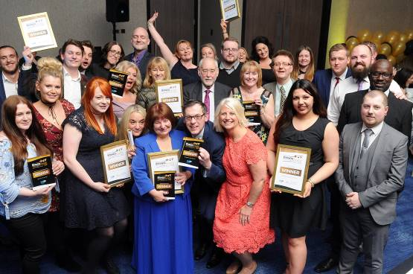

Category winners at the HullBID Awards 2018 at the DoubleTree by Hilton Hotel

EXECUTIVE DIRECTOR’S SUMMARY

As we enter into the third year of BID Term 3, we can reflect on a successful 2018 and look forward to an exciting year of opportunity in 2019.

Although we have seen our BID levy income decline, pleasingly we will generate significant additional income from sponsorship and stallholder fees as our popular events including Hull Street Food Nights and the Yum! Food Festival continues to grow in popularity. Along with extra funds from grants secured, our revenue will be boosted by approximately 25%.

The City of Culture legacy continues to impact positively on Hull city centre and we have been buoyed to see continued growth in footfall; in the number of new businesses entering the city and importantly a reduction in the numbers of empty units.

The climate is still a difficult one – who cannot be saddened by the closure of House of Fraser and others – but we are seeing some green shoots. Retailers particularly are recognising how people spend their money differently seeking an all-round experience. It is pleasing therefore to see so many businesses adapting their ways of operating to meet demand.

It is vitally important that we strive to attract visitors from the region and sub-region by presenting an offering that is unique.....our events and festivals, our maritime heritage, our free museums and our historic old town to name a few will continue to boost numbers. With this in mind, along with partners, we will seek to deliver a vibrant TV advertising campaign showcasing the city at is best.

As an organisation we play our part in helping keep the city centre safe and secure. We have witnessed an increased PCSO presence - a commitment made following our dialogue with the Police and Crime Commissioner - yet as we deal with more homeless and begging on the streets, the work of the HullBID Support Officers is essential in providing that extra layer of immediately accessible security. Our sourcing of grants will also see our radio system – a communication tool between the BID, the Police and Civic 1 - upgraded with new digital handsets which will be rolled out in December and into early January 2019. We hope to replace every handset in use.

Hull Street Food Nights has been a spectacular success and we look forward to moving to our new home in Trinity Square. Similarly the HullBID Awards and Yum! Festival of Food and Drink are set to continue... only bigger and better. A few new initiatives are in the pipeline; our commitment to supporting the health and beauty sector will see our involvement in a ‘Beauty Exhibition’ event taking place and our plans for a bespoke Food and Drink Trail are gathering momentum.

We continue to have regular dialogue with our members on issues that affect them, from the successful Evening Economy Group meetings to smaller, trader group meetings. With our representation on the Place Management Chairs’ Group and other Council-led groups, we are perfectly positioned to share news and information with our members. And.... we are at the end of a phone – always contactable, always approachable, always here to help.

Thank you - Kathryn Shillito, Executive Director, HullBID

STRATEGIC FOCUS

OBJECTIVE | OUTCOME | MEASUREMENT
To return to grass roots, with focus on 4 key activities  Improving Security  Improving Cleanliness  Improving Communications  Improving Business | To rubber-stamp our commitment to businesses to improve the trading environment | Maximum of 24 hours response time to deal with queries and requests
To provide an opportunity for business to directly challenge Humberside Police for extra resources | Businesses have sense of control and can make direct requests | Greater satisfaction from businesses that they are listened too
Utilise HullBID profile to lobby on the bigger issues that are a threat | Key decisions, particularly by public bodies are influenced | A thorough understanding by decision-makers of threats to the wellbeing of the city centre
To develop existing BID events to become 100% self-sustaining | BID funds can be used to develop new events and initiatives for target sectors | Wider range of sectors satisfied that funds are being apportioned in a balanced way
To attract voluntary levy payers (those with £5k or under threshold) | Additional funds to invest and greater buy-in by small businesses | Understanding of how small business integrates into the bigger picture of a thriving city centre
To attract sponsorship | Existing events grow; a wider programme of initiatives are delivered | Less reliant on income from BID levy
To work more cohesively with our partners Hull City Council to improve the environment | Regular dialogue to take place. HullBID to be briefed on anything affecting the city centre | Less disruption to members who can plan/adapt at an early stage
To maintain the profile of HullBID with members and in the media | HullBID is viewed as an organisation with extensive knowledge about the city centre | Increased number of positive news stories reported
To achieve a successful ballot in 2021 | A heightened number of ‘yes’ votes than 2016 | Above an 80% majority

O U R V I S I O N A N D V A L U E S

OUR VISION…
‘A vibrant city of thriving businesses’
A reminder of what it is that we wish to achieve when we turn up to work – regardless of our individual role in the BID organisation. This is about our end goal. We know we play a key role in achieving this, but recognise we can’t do it on our own. We need to work in partnership with other city stakeholders groups and the business community. Our strategy reflects this awareness
OUR VALUES…
Our values provide a model for how we need to operate. We live these values everyday to ensure we realise our vision.

HullBID exists to help businesses in the city sustainably grow and progress. We will organise our activity around four core pillars representing the important roles we play in facilitating the development of prosperity in Hull city centre.

These core pillars will remain constant irrespective of the actual activities. By staying true to our pillars, we can adapt and change our tactics and operations plans to meet the changing needs of the business community whilst maintaining a consistent strategic and communicative approach.

Core Pillar: COMMUNICATION
‘We are visible, vocal and an active part of the business community’. Our objective is to be respected and recognised by at least 75% of levy paying businesses as a visible and active part of the business community.

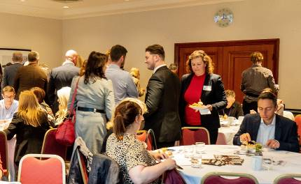
We Communicate: A BID Members’ Network Event

Core Pillar: INNOVATION
‘We plant and sow seeds and ideas’. Our objective is to develop a minimum of two successful development initiatives in the 2018-2019 year.
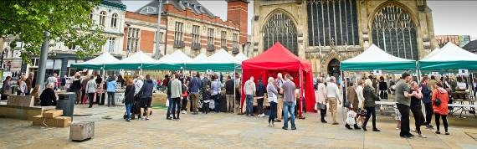
We Innovate: Hull Trinity Farmers’ Market enabled small BID businesses to showcase their goods

Core Pillar: PROMOTION
‘We actively promote the benefits of investing in Hull city centre’. Our objective is to work with partner organisations to promote the benefits of investing in Hull city. We work towards increased footfall, a decrease in empty units and greater interest in the city centre.
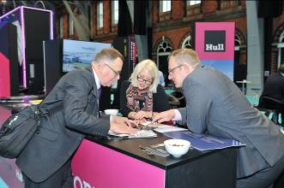
We Promote: HullBID co-host a stand at the REVO (Retail Evolution) exhibition.

Core Pillar: COLLABORATION
‘We deal with the bigger issues that require a collective approach’. Our objective is to be considered the ‘champion of businesses’ by more than 70% of BID levy payers.
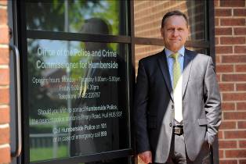
We Collaborate: A commitment to long-term extra policing was achieved through negotiations with the Humberside Police and Crime Commissioner, Keith Hunter

WHAT WILL HULLBID’S INCOME BE FOR 2018/2019 AND
WHERE WILL IT BE SPENT?

In the 2018-2019 financial year we anticipate an income of approximately £422,125 from the BID levy (which includes a surplus carried forward from the previous year) and an additional £65,436 will be raised via sponsorship and stallholder income totalling £487,561. Below is an indicative budget. Note: may be subject to change.

EXPENDITURE | ACTIVITY (not exhaustive) | AMOUNT
Safety & Security | - Two full-time, mobile Support Officers  - Part-funding towards additional PCSO’s  - Provision of radios and consumables | £59,930
Marketing/Events | - Yum! Food & Drink Festival  - HullBID Annual Awards  - Health and Beauty Expo  - Christmas Street Food & Market Event  - TV Advertising Campaign  *Not exhaustive | £111,829
Communications | - E Newsletter to all members  - PR and photography - new member businesses  - Promotional Brochure (TBC)  - BID Business Networking Events  - Stationary/phones/office commodities | £19,300
Rapid Response/Lighting | - Full-time cleaning and maintenance operative. Budget inc. van/jet-spray machine/chemicals  - Funding for erection/dismantling of Christmas lighting schemes (HCC) | £28,300
Evening Economy | - Food and Drink Trail (map)  - Hull Street Food Nights – April to September. | £42,600
Access/Signage | - 7 footfall counters strategically positioned to count footfall (Springboard)  - Empty unit graphics | £23,764
Management fees | - Staffing  - Chamber of Commerce management fee  - Rent/Utilities  - Professional and sundry costs | £128,323
Levy collection/IT | - Collection costs/IT upgrade – Hull City Council | £32,450
Contingency | Contingency brought forward from the 2017/2018 year | £41,065
 | TOTAL | £487,561

Do HullBID draw in any extra funds?

We talk an awful lot about adding value and this comes in many forms including cash funding to in-kind support (which has a value). Below is a projection of minimum additional income for the 2018/2019 year. We will continue to demonstrate to potential sponsors the benefits of being a part of our activities and initiatives.

Source | Initiative/Activity | Income
Stallholders | - Yum! Food Festival  - Hull Street Food Nights  - Christmas Street Food & Crafts Market | £37,500
BID member business | - Overall sponsorship of Hull Street Food Nights | £6,000
BID member businesses – various | - Category sponsors of the Hull Business Improvement District Awards (BIDA’s) | £5,000
Office of the Police and Crime Commissioner | - Contribution towards replacement of HullBID radios | £9,958
BID member business | - Contribution towards footfall counter cost | £1,978
BID member business | - Overall sponsorship of the Yum! Festival of Food and Drink | £5,000
 | TOTAL | £65,436
Note: At the time of writing, grants totalling approximately £25,000 are being sourced from the Big Lottery Fund and other charitable institutions to provide further new radio handsets.

SERVICES WE’LL DELIVER IN 2018-2019

WE’LL CONTINUE HELPING KEEP THE CITY CENTRE SAFER – WE KNOW OUR BUSINESSES VALUE THE SUPPORT THEY RECEIVE.

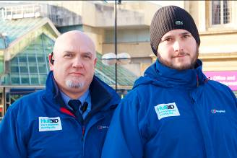
Mark Andrews, Senior Support Office and Raich Orr, Support Officer

We were delighted to secure a grant from the Office of the Police and Crime Commissioner to upgrade our HullBID Radio System, enabling us to replace a proportion of our old, worn analogue radio handsets with new digital handsets. We anticipate a further boost to the radios budget following our approach to various charitable bodies (including the Big Lottery Fund). The radio system is a vital tool in dealing with anti-social behaviour and the prevention of theft.

Our two dedicated BID Support Officers patrol the city centre daily from 9.30am until 6pm Monday to Friday. Their presence offers a sense of safety and security particularly when businesses are confronted with anti-social behaviour and petty theft.

Their communications and regular meetings with other stakeholders including Emmaus, Humberside Police and Hull City Council provides further insight into issues which are currently dominating the headlines. We have seen a steep rise in the number of homeless and begging and their personal engagement with people on a daily basis means they can both summon medical assistance if needed, or pass on information to the police if crimes are committed. The BID Officers’ support has proved vital to our members, particularly when police resources are directed to an out of town issue.

Our highly-respected Retail Security Forum organised and chaired by Mark Andrews, Senior Support Officer brings together the Police, the Council’s anti-social behaviour officer and over 20 (large) store security teams once a month to share intelligence and data.

WE’LL KEEP THE CITY CENTRE CLEAN OF GRAFFITI, REMOVING UNWANTED
WASTE AND MESS

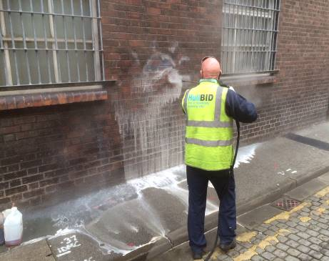
Cleaning and Maintenance operative Martin Foster removing graffiti

Once the scourge of the city centre, our full-time operative works hard to remove unsightly graffiti from private and public property. Small and large areas are jet-sprayed to remove nuisance chewing gum and bring streets, particularly those with heritage significance back to life. Human waste and detritus left by rough sleepers will be swiftly eradicated. A focus will be given to car parks, particularly public multi-storeys as we know these are areas of concern.

It is important that visitors to the city centre are given a good impression and we pride ourselves on delivering a cleaning service that reacts immediately to demand with mess and waste cleared away within a 24 hour period.

EVENTS, ACTIVITIES AND INITIATIVES WE’LL DELIVER IN 2018-2019

HULL BID ANNUAL AWARDS

The highly-anticipated HullBID Awards will attract nominations from hundreds of BID businesses, their customers and the general public. The awards have gone from strength to strength since their inception five years ago and in 2019 the magnificent Hull Minster will provide illustrious surroundings for this black tie event.

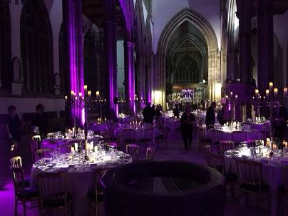
Hull Minster... venue for the HullBID Awards 2019

The Awards continue to provide recognition and reward to any member/s of any BID business with extensive PR coverage in the Hull Daily Mail, who we partner with to promote the event. Shortlisted businesses will receive complimentary tickets. This event will be 40% funded via sponsorship.

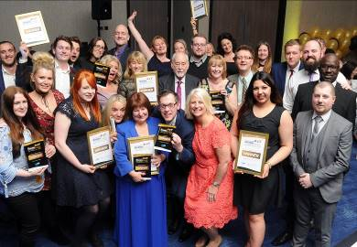
Winners at the HullBID Awards 2018

YUM! FESTIVAL OF FOOD AND DRINK

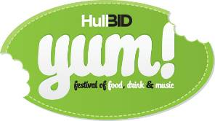

We’ll continue to deliver successful events including the Yum! Festival of Food and Drink which year-on-year brings increased footfall (35,000 visitors attended in 2018). With good representation from BID foodie businesses, this event brings increased revenue for all. The Yum! Festival will be 80% funded from stallholder income.

In 2019, we’ll return to our ‘grass roots’, reintroducing the chefs’ stage and encouraging the best of city centre chefs to demonstrate their skills. Our aspiration is to also partner with Hull College to promote their catering department by organising a cooking competition which will see students pitching against each other for a coveted prize.

We will put more emphasis on delivering games and activities for younger family members whilst creating a vibrant beer garden with live music for the over 18’s. Our strong ethos of providing a ‘free to enter’ event will ensure that any spend goes directly to stallholders.

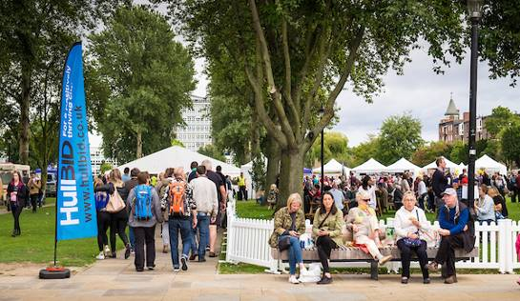
The Yum! Festival of Food and Drink continues to grow.

SUPPORT FOR THE EVENING ECONOMY

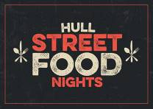
The Award-winning Hull Street Food Nights returns

One of our biggest successes in support of the early evening economy is Hull Street Food Nights. Originally introduced to support City of Culture activity, this event will see over 50,000 people people enjoying the best of street food, complemented with superb live music and entertainment.

In 2019 we will move Hull Street Food Nights back into the historic and beautiful surroundings of Trinity Square, with over 45 foodie businesses supplying high-quality food. Integral to its success will be the participation of Hull Minster and Trinity Indoor Market, providing weather-proof surroundings along with plenty of seating.

We will operate over the summer months from April to September, 4pm until 9pm, enabling revellers to continue their evening in surrounding pubs and bars. These events will be 90% funded from sponsor and stallholder income.

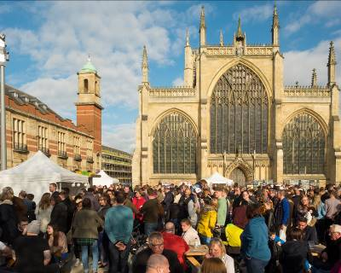
Hull Street Food Nights will return to Trinity Square, Hull Minster and Trinity Market in 2019

NEW FOR 2019.....Food and Drink Map
2019 will see us introduce a brand new initiative.... The Food and Drink Trail will pinpoint all BID member food and drink businesses on one easy to read map. Ideal for those visiting the city, the map will be portable and will provide the discerning drinker information about the best cask-ale pubs in the city. Equally, those looking for a lively night; for a great plate of tapas or a relaxing evening listening to acoustic music will be able to head straight to a venue of their choice.

NEW FOR 2019....TV Advertising Campaign
Hot on the heels of our City of Culture success (and of our ‘Wonderf-Hull’ Christmas TV advertising campaign!), we will work with partners to deliver an ITV advertising campaign highlighting all that is good about Hull city centre. The events, the festivals, the architecture, the shopping, the food, the people and more. The city must continue to attract greater visitor numbers.... we believe an advertising campaign will plant Hull firmly in the minds of viewers in the region and sub-region acting as a reminder of what has and can be achieved.

WORKING WITH OUR PARTNERS

Place Management Chairs’ Meetings – hosted by Hull City Council
Joining this group at the invitation of Mark Jones, Director of Regeneration of Development, puts HullBID in a positive position. We are able to learn first-hand of investments, positive news or indeed issues that affect the city centre. Topics discussed range from news of potential investors to residential developments and a great deal more. The BID is able to share perspective, ensuring that the interests of our members are represented. We are able to challenge on issues that may pose a threat, but importantly we can offer our support on ideas and initiatives that further develop and grow the city centre. It is indicative of the goodwill between the Council and HullBID – we both share a common goal.

Humberside Police
The partnership between HullBID and Humberside Police is positive... from our meetings with the Police and Crime Commissioner, to regular attendance from Police representatives in support of our evening economy meetings. Our members are naturally concerned with safety and security on the streets and it is reassuring that we can call on our colleagues within the force to provide guidance and assurance, whether that is by personal visits made to businesses or addressing a wider audience. No-one is under any illusion that policing in the city centre is easy given the reduction in resources, but the partnership working, particularly via the BID radio system, has provided greater protection.

Culture and Place Strategic Advisory Board

As a member of the Culture and Place Strategic Advisory Board (CAPSA), HullBID contributes a city centre business perspective, integral to the strategy for culture through to 2026 supporting the legacy of City of Culture. The strategy will focus on three areas.... Developing the City, Developing the Audience, Developing the Sector


UK City of Culture 2017: Made In Hull Event

We are committed to offer every assistance to Absolutely Cultured and Hull City Council, continuing to build on the superb success of our year in the spotlight. The foundation has been laid and the cultural strategies adopted now will be integral to the city’s success.

Scheduled meetings with our members
The Executive Director will continue to schedule meetings with key businesses, including shopping centre managers and larger organisations, however any request to meet from a business will be obliged. Our new Business Liaison Officer will immediately target new businesses coming onto charge; this way they are fully briefed about the levy and all the benefits associated with HullBID, prior to receiving an invoice. It is anticipated that a minimum of 10 visits per week will be carried out.

FREQUENTLY ASKED QUESTIONS:

What is a BID?
A Business Improvement District (BID) is a defined geographical area where, in Hull’s case, the boundary covers the nucleus of the city centre bounded by Freetown Way,
the East Bank of the River Hull, the River Humber and Ferensway. Currently there are over 290 Business Improvement Districts within the UK.

As a not for profit organisation (a company limited by guarantee), HullBID is funded and operated independently with its own team. HullBID represents the interests of approximately 750 member businesses across 1184 hereditaments.
Note: A hereditament is any business premise that is liable to pay business rates.

In the majority, a BID runs for a five year term as is the case with HullBID. Prior to expiry of the term, a renewal ballot takes place where businesses are given the opportunity to either vote in favour or against a BID being implemented.

Is HullBID under the control of Hull City Council?
HullBID is not run by the local authority, nor is it exclusively in the hands of businesses. As an independent organisation, it is designed to unite people from city centre business and from the providers of public services in partnership to identify and deliver the action that is needed to improve the area. BIDs do not replace local authorities, police forces or other public bodies. Baseline service level agreements are set with those bodies and HullBID provides specific and enhanced improvements over and above statutory services.

How is HullBID funded?
HullBID is funded via an additional levy equivalent to 1% of the rateable value of a business premise. The levy is collected on behalf of HullBID by Hull City Council who send out an annual invoice approximately June time. Subject to a successful ballot, the levy is mandatory and all businesses are required to pay. Owners/landlords of unoccupied premises will still be required to pay the levy. Properties eligible for charitable relief of 80% of their non-domestic rates will be required to pay the levy on the remaining 20%.

How do you prioritise your spending?
We have prioritised spending according to our members’ wishes and carefully measure the success of each initiative. We are conscious our members' money needs to be well-controlled and spent thus we have deliberately kept our team small to manage one of the UK’s biggest BIDs.

In cost terms, how much is my business likely to pay?
Bearing in mind the levy is based on 1% of the RV of your business premise, below is an indication of the cost you will incur.

RV OF PROPERTY ANNUAL LEVY COST WEEKLY COST DAILY COST
£5,000 £50 £0.96 £0.14
£10,000 £100 £1.92 £0.27
£15,000 £150 £2.88 £0.41
£20,000 £200 £3.85 £0.55
£50,000 £500 £9.60 £1.37
£100,000 £1,000 £19.23 £2.75

Who pays the highest levy?
PREMISES | AMOUNT CONTRIBUTED
Hull City Council | £38,403
Tesco Stores Ltd | £24,229
Hull College | £11,338
Princes Quay Estates Limited | £10,486
Primark Stores Ltd | £7,850
House of Fraser – In Administration | £7,000
Hull Crown Court | £6,900
Debenhams Plc | £6,250
Brayford Hotels (DoubleTree) | £5,350
Next Plc | £5,150

What are some of your significant achievements?
HullBID has achieved some great things over the last 5 years. The city centre is a measurably cleaner and safer place to do business. We’ve pulled together further with city stakeholders including Hull City Council, VHEY, Humberside Police and Civic 1 (the city’s CCTV operations hub). Our BID radio scheme goes from strength to strength, as do numbers attending our exciting events. Equally important, we have shown our strength as a lobbying organisation, bringing together businesses to take action on matters which affect Hull city centre.

O U R B O A R D A N D T E A M

EXECUTIVE DIRECTOR
- Kathryn Shillito

NON-EXECUTIVE DIRECTORS
- Jim Harris, Centre Manager, St Stephens (Chair)
- Dr Ian Kelly, Chief Executive, Hull & Humber Chamber of Commerce
- Councillor Darren Hale, Deputy Leader, Hull City Council
- Garry Taylor, City Manager, Major Projects & Infrastructure, Hull City Council
- Guy Falkingham, Managing Director, Yorkshire Brewing Company
- Victoria Jackson MBE, Kingston Recruitment
- Tim Powell, Partner, Scotts
- Julie Buffey, Owner, Roisin Dubh
- Mike Rice, Chairman, Hugh Rice Jewellers
- David Donkin, Property Director, Wykeland
- Nigel Dibb, General Manager, Holiday Inn Hull Marina
ALL NON-EXECUTIVE BOARD DIRECTORS ARE UNREMUNERATED AND GIVE THEIR TIME FREELY

OPERATIONAL TEAM
- Catherine Goble, Marketing & Events Coordinator (full time)
- Mark Andrews, Senior Support Officer (full time)
- Raich Orr, Support Officer (full time)
- Lucilla Bathurst, Business Liaison Officer (16.5 hours)
- Francesca Sharp, PA/Office Administrator (16.5 hours)
- Martin Foster, Cleaning and Maintenance Operative (full-time)

FOOTFALL AND STATISTICS

We’ll closely monitor footfall gathered from our 7 footfall counters to measure any trends and draw comparisons with other cities. Up-to-date information on vacancy rates and new occupants / vacations is provided to BID members on a weekly basis. Footfall stats for bespoke areas at specific times are available on demand.

DELIVERABILITY AND RISK

There are no technical or legal barriers from an organisational perspective that will prevent implementation and delivery of this plan.

CONTACT DETAILS
Kathryn Shillito, HullBID Executive Director, HullBID. Tel: 01482 611889
Registered Office: 34-38 Beverley Road, Hull HU3 1YE www.hullbid.co.uk

Note: Business plan may be subject to change. Our funding is subject to fluctuation which may increase or decrease and will be reflected accordingly across our budget and our implementation of initiatives. At the time of writing, it is believed that all information contained is correct but no liability or responsibility can be attached to HullBID

