

BUSINESS PLAN – 2018/2019
(1 October 2018 to 30 September 2019)

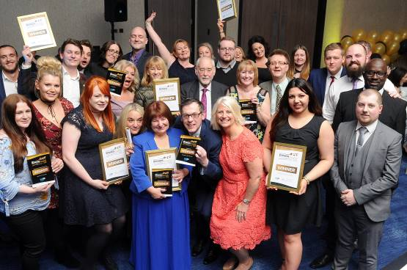

Category winners at the HullBID Awards 2018

EXECUTIVE SUMMARY
As we enter into the second year of BID Term 3, we can reflect on an extremely exciting and successful 2017 and look forward to 2018 with equal gusto. The City of Culture year has been phenomenal in animating the city centre and promoting Hull to a global audience.

Anecdotally our members are reporting increased business with more staff recruited to deal with demand. It is vital we continue to collaborate with the new Culture Company, sharing information and helping develop ideas that will benefit our members.

In preparation for our year in the spotlight, our members endured a period of disruption during improvements to the public realm with many struggling due to diminishing footfall. However, since its completion there has been an overwhelmingly positive reaction and Hull City Council is to be congratulated for taking this ambitious and bold step.

Hot off the success of Hull Street Food Nights, we look forward to introducing new events and initiatives to our calendar which will capture different audiences, and we’ll work closely with BID members to bring these to life. We believe that our young professionals are key to further-developing a successful city centre and look forward to building our ‘Young Professionals’ network. It is vital we nurture and harness skills honed, particularly in a fast-paced digital world, and do our utmost to prevent this talent base from seeking opportunities elsewhere.

A determined effort will be made, along with partners, to attract new retail to Hull City Centre and our participation at the REVO 2018 Exhibition is vital. Similarly we await further news on the proposed Albion Square and Myton Street developments, and will engage closely with Hull City Council and any private sector partners. We will persist in lobbying against the proposed 10-unit extension at Kingswood and will consider appropriate action against anything that is a threat to city centre businesses.

We continue to have regular dialogue with our members on issues that affect them, from the successful Evening Economy Group meetings to smaller, trader group meetings. With our representation on the Place Management Chairs’ Group and other Council-led groups, we are perfectly positioned to share news and information with our members. And.... we are at the end of a phone – always contactable, always approachable, always here to help.

Thank you - Kathryn Shillito, City Centre Manager, HullBID

O U R V I S I O N A N D S T R A T E G Y

OUR VISION…
‘A vibrant city of thriving businesses’
A reminder of what it is that we wish to achieve when we turn up to work – regardless of our individual role in the BID organisation. This is about our end goal. We know we play a key role in achieving this, but recognise we can’t do it on our own. We need to work in partnership with other city stakeholders groups and the business community. Our strategy reflects this awareness
OUR VALUES…
Our values provide a model for how we need to operate. We live these values everyday to ensure we realise our vision.

HullBID exists to help businesses in the city sustainably grow and progress. We will organise our activity around four key strategic pillars representing the important roles we play in facilitating the development of prosperity in Hull city centre.

These strategic pillars will remain constant irrespective of the actual activities. By staying true to our strategic pillars, we can adapt and change our tactics and operations plans to meet the changing needs of the business community whilst maintaining a consistent strategic and communicative approach.

OUR FOUR KEY STRATEGIC PILLARS
COMMUNICATION
INNOVATION
PROMOTION
COLLABORATION
CORE PILLAR: COMMUNICATION

’We are visible, vocal and an active part of the business community’. Our objective is to be respected and recognised by at least 75% of levy paying businesses as a visible and active part of the business community.
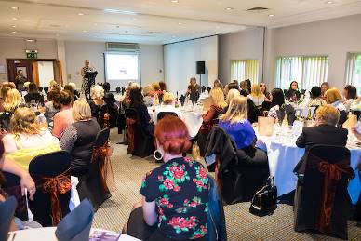
We Communicate: BID members attend the ‘Inspiring Women’ Dinner during Humber Biz Week 2017

This means that we will….

- Build credibility amongst key stakeholders in the city centre as an expert on Hull city centre growth and development.

- Increase spontaneous awareness amongst member businesses about the purpose of HullBID

- Engage levy payers and drive interest in getting involved in HullBID activities

- Facilitate member involvement and engagement in HullBID’s strategies; ensuring they have a voice

- Always respond to our levy payers in an appropriate and reasonable time frame

- Reflect on our values in all of our communications

- Encourage and provide opportunities for two-way communication

- Communicate, giving enough time to allow people to respond

How we’ll achieve our objectives:

- Revitalise social media and e news communications to reflect our vision, values and purpose.

- An annual, comprehensive media and communications strategy will be implemented to raise greater awareness of city businesses and city activity

- Deliver a consistent relationship strategy and postcard/letter follow up.

- Represent our member businesses within all areas of the city centre with our partners Hull City Council and other stakeholders.

- Adapt the quarterly newsletter to an online version, to include newsworthy topics and provide a platform to showcase existing and new businesses.

- New member businesses will be offered personal PR support at no cost.

- Immediate visits to new businesses offering a one-to-one service and deal with any issues arising therefrom.

Measurement of our success:

- Comprehensive press logs will be kept.
- Number of contacts made from the press (for interviews, quotes etc)
- Language used to describe HullBID is positive
- Face to face feedback (number of visits/contacts)
- Survey results
- Network registrations and feedback
- Social media mentions
- Minutes will be retained on website

CORE PILLAR: INNOVATION
‘We plant and sow seeds and ideas’. Our objective is to develop 3 successful development initiatives in the 2017-2018 year.

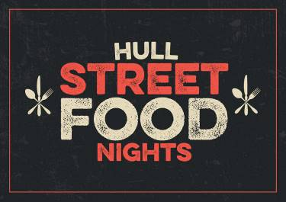
We Innovate: Hull Street Food Nights, one of 3 new initiatives developed in 2017, will continue in 2018

This means that we’ll…

- Build a comprehensive network to help share and promote events, initiatives and local companies.

- Plant the initial seed for ideas and events and let others continue when they’re established.

- Be assertive and active in driving Hull and its businesses forward.

- Focus on initiatives which make a measurable difference – don’t spread ourselves too thinly.

- Build confidence in our ability to initiate successful activities with impact.

How we’ll achieve our objectives…

- Actively solicit the input and expertise from Hull BID businesses – get them inspired and excited about the development of new ideas.

- Research other BID’s case studies and successes

- Ensure new initiatives support different sectors

- Work with focus groups to develop a pool of ideas for business development initiatives, resulting in a shortlist of top ten highest-impact, quickest-win ideas.

Measurement of our Success
- Numbers of people attending group meetings and workshops
- 3 business boosting ideas chosen and implemented per year
- High level of support from BID businesses for ideas proposed (feedback, number of volunteers etc)
- Clear and measurable results i.e. increase in footfall/excellent response to consumer surveys

CORE PILLAR: PROMOTION

‘We actively promote the benefits of visiting Hull city centre’. Our objective is to work with relevant agencies to promote the benefits of visiting Hull city centre whilst aiming to increase footfall each year.

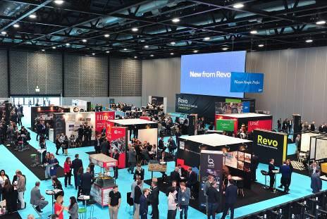
We Promote: Revo Exhibition where a stand will be co-hosted with HCC and other partners

This means that we’ll…
- Increase the number of HullBID members satisfied with our promotional and events based activities in the city to 75%

- Deliver relevant, high-quality events that measurably increase city centre footfall working in partnership where appropriate.

- Work with our partners to put focus on improving Hull’s evening economy.

- Get to know which initiatives are really valuable and important to HullBID members and focus on delivering those.

- Make removing barriers and improving trading opportunities a key priority.

How we’ll achieve this objective…

- Continue to work with other agencies involved in promotion with a more coordinated approach and set objectives.

- Collaborate with the new Culture Company CEO and team, taking an active role in developing new ideas and initiatives and sharing news with members

- Update our Business Directory on the HullBID website to ensure each BID member is represented... a one-stop shop for any service.

- Co-host a stand at REVO 2018 with partners Hull City Council and VHEY, and thereafter facilitate familiarisation trips for potential investors.

- Offer sponsorship packages for our key events to enable BID members to be involved and promote their individual business.

Measurement of our Success…

- Increased positive feedback about HullBID events by our members.
- Strong promotional partnerships built with other city stakeholders.
- Plans for a developed early evening economy emerge.

CORE PILLAR: COLLABORATION

‘We deal with the bigger issues that require a collective approach’. Our objective is to be considered the ‘champion of businesses’ by more than 70% of BID levy payers.

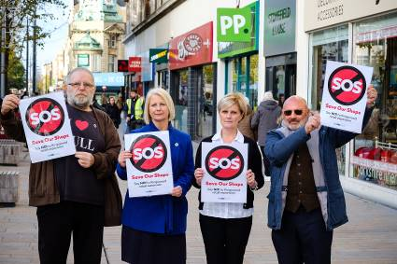
We Collaborate: City centre businesses joined forces to campaign successfully against Kingswood expansion

This means that we’ll…

- Build credibility amongst stakeholders in the city centre for being a conduit for business information.

- Build a network to help share and promote events and initiatives.

- Develop partnerships with other authorities and agencies to develop Hull city centre.

- Within our powers, we will lobby for the big issues that really make an impact.

- Continue to help keep the streets accessible, attractive and safe.

How we’ll achieve our objectives…

- Engage with city stakeholders on a regular basis (Bondholders, Hull College, and the City of Culture Team).

- Continue to encourage businesses to attend working groups and forum meetings.

- Update our welcome brochure to be more concise and relevant

- Collaborate with Keith Hunter, Humberside Police and Crime Commissioner to help promote the city centre as a safe destination.

- Work with the city’s Environmental Heath Team ensuring illegal rubbish dumping is strictly dealt with and perpetrators brought to account.

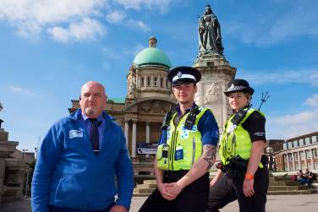
We Collaborate: Mark Andrews, HullBID Senior Support Office Chairs the Retail Security Forum

- A comprehensive cleaning and maintenance schedule will be delivered by our maintenance operative including jet-spraying/graffiti and gum removal

- Seek opportunities to provide free or reduced cost car parking within Hull city centre and continue to engage with Hull City Council and independent operators.

Measurement of our Success

- Improvement in members’ perception
- Number of members sharing expertise and connecting using website area
- Number of lobby/campaigns/barrier removals successfully achieved.

O U R B O A R D

EXECUTIVE DIRECTOR
- Kathryn Shillito

NON-EXECUTIVE DIRECTORS
- Jim Harris, Centre Manager, St Stephens (Chair)
- Dr Ian Kelly, Chief Executive, Hull & Humber Chamber of Commerce
- Garry Taylor, City Manager, Major Projects & Infrastructure, Hull City Council
- Guy Falkingham, Managing Director, Yorkshire Brewing Company
- Victoria Jackson MBE, Kingston Recruitment
- Tim Powell, Partner, Scotts
- Julie Buffey, Owner, Roisin Dubh
- Mike Rice, Chairman, Hugh Rice Jewellers
- David Donkin, Property Director, Wykeland
- Nigel Dibb, General Manager, Holiday Inn Hull Marina
ALL NON-EXECUTIVE BOARD DIRECTORS ARE UNREMUNERATED

OPERATIONAL TEAM
- Catherine Goble, Marketing & Events Coordinator (full time)
- Mark Andrews, Senior Support Officer (full time)
- Raich Orr, Support Officer (full time)
- Lucilla Bathurst, Business Liaison Officer (16.5 hours)
- Francesca Sharp, PA/Office Administrator (16.5 hours)
- Martin Foster, Cleaning and Maintenance Operative (full-time)

WHAT WILL HULLBID’S INCOME BE FOR 2017/2018 AND
WHERE WILL IT BE SPENT?

In the 2018-2019 financial year we anticipate an income of approximately £422,125 from the BID levy and an additional £65,436 will be raised via sponsorship and stallholder income etc totalling £487,561. We anticipate, as we further progress into the year, our additional income will be further boosted, equating to approximately 20%-25% of the levy income. Below is an indicative budget (may be subject to change).

EXPENDITURE | ACTIVITY (not exhaustive) | AMOUNT
Safety and Security | - Two full-time, mobile Support Officers  - Funding towards additional PCSO’s  - Provision of radios and consumables | £55,375
Marketing/Events | - Yum! Food & Drink Festival  - HullBID Annual Awards  - The Beauty Box  - Hull Farmers’ Market  - Christmas activity  - Young Professionals Network | £118,805
Communications | - E Newsletter to all members  - PR and photography (for new member businesses)  - Brochures inc. new members ‘welcome’ brochure  - BID Business Networking Events  - Stationary  - Mobile phones | £24,300
Rapid Response/Lighting | - Full-time cleaning and maintenance operative. Budget inc. van/jet-spray machine/chemicals  - Funding for erection/dismantling of Christmas lighting schemes (HCC) | £27,000
Evening Economy | - Christmas Street Food Night event  - Hull Street Food Nights – April to September. | £46,000
Access/Signage | - 6 footfall counters strategically positioned to count footfall (Springboard)  - Empty unit graphics | £23,764
Management fees | - Staffing  - Chamber of Commerce management fee  - Rent/Utilities  - Professional and sundry costs | £115,232
Levy collection/IT | - Collection costs/IT upgrade – Hull City Council | £32,450
Contingency | - | £47,591
 | TOTAL | £490,517

Do HullBID draw in any extra funds?
We talk an awful lot about adding value and this comes in many forms including cash funding to in-kind support (which has a value). Below is a projection of anticipated income for the 2017-2018 year. We will continue to demonstrate to potential sponsors the benefits of being a part of our activities and initiatives.

Source | Initiative/Activity | Approx income
Stallholders | - Yum! Food Festival  - Hull Street Food Nights  - Farmers’ Market | £52,600
BID Member business | - Overall sponsorship of above events | £5,000
BID member businesses - various | - Category sponsors of the Hull Business Improvement District Awards (BIDA’s) | £4,000
BID member businesses – various | - Sponsor of Young Professionals Group | £1,000
 | TOTAL | £62,600

WHAT WE’LL DELIVER IN 2017-2018

WE’LL CONTINUE HELPING KEEP THE CITY CENTRE SAFER – WE KNOW OUR BUSINESSES VALUE THE SUPPORT THEY RECEIVE.
Our two dedicated BID Support Officers patrol the city centre daily from 9.30am until 6pm Monday to Friday. Their presence offers a sense of safety and security particularly when businesses are confronted with anti-social behaviour and petty theft.

Their communications and regular meetings with other stakeholders including Emmaus, Humberside Police and Hull City Council provides further insight into issues which are currently dominating the headlines. We have seen a steep rise in the number of homeless and begging and their personal engagement with people on a daily basis means they can both summon medical assistance if needed, or pass on information to the police if crimes are committed. The BID Officer’s support has proved vital to our members, particularly when police resources are directed to an out of town issue.

Our highly-respected Retail Security Forum organised and chaired by Mark Andrews, Senior Support Officer brings together the Police, the Council’s anti-social behaviour officer and over 20 (large) store security teams once a month to share intelligence and data.

The HullBID Radio System pulls over 200 businesses together with the added protection of linking into the Police and Civic CCTV and is a vital tool in helping keep businesses safe.

WE’LL KEEP THE CITY CENTRE CLEAN OF GRAFFITI AND GRIME

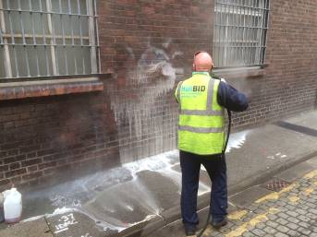
Cleaning and Maintenance operative removing graffiti

Once the scourge of the city centre, our full-time operative works hard to remove unsightly graffiti from private and public property. Small and large areas are jet-sprayed to remove nuisance chewing gum and bring streets, particularly those with heritage significance, back to life. Human waste and detritus left by rough sleepers will be swiftly eradicated.

EVENTS AND ACTIVITIES
In 2018 we’ll continue to deliver successful events including the Yum! Festival of Food and Drink which year-on-year brings increased footfall (25,000 visitors attended in 2017). With good representation from BID foodie businesses, this event brings increased revenue for all. The Yum! Festival will be 65% funded from stallholder income.

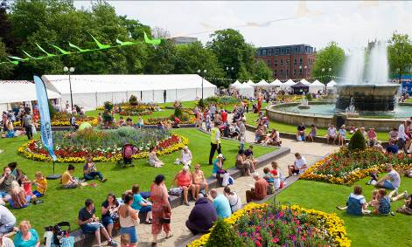
The Yum! Festival of Food and Drink continues to grow.

HULL BID AWARDS
The highly-anticipated HullBID Awards will attract nominations from hundreds of businesses, their customers and the general public. The Awards provide recognition and reward to any member of any BID business with extensive PR coverage given in the Hull Daily Mail, who we partner with to promote the event. The prestigious 2018 Awards will take place at the Double-Tree by Hilton Hotel and shortlisted business will receive complimentary tickets. This event will be 50% funded via sponsorship.

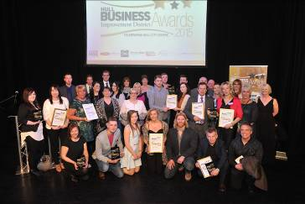

SUPPORT FOR THE EVENING ECONOMY
One of our biggest successes is Hull Street Food Nights. Originally introduced to support City of Culture activity, this event helped bridge the early evening economy gap with over 60,000 people enjoying the best of street food, complemented with superb live music and entertainment. Our intention is to build on its’ success with 6 dates from April to September 2018 when more BID members will be invited to participate. These events will be 90% funded from sponsor and stallholder income.

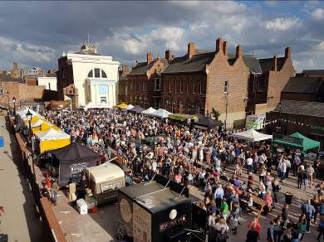
Aerial view of Hull Street Food Nights, Zebedee’s Yard. A Christmas Street Food event takes place in December.

NEW FOR 2018.....THE BEAUTY BOX
2018 will see us introduce a brand new initiative. The Beauty Box idea was borne from regular meetings with our larger retailers, who saw scope in providing an ‘out of premises’ space where their teams of beauticians could offer free make-overs and more. The Beauty Box, a purpose-built marquee will be sited once a month on Jameson Street and will be bustling with experts from the beauty field, providing a benefit for those visiting whilst promoting retail brands to the public. There is huge scope to expand this event by engaging with our retail businesses, and introducing mini fashion shows and more.

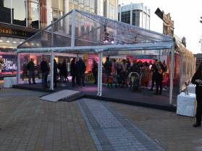
The Beauty Box marque... live demos and more (image for guidance only – size/design may differ)

NEW FOR 2018....OUTDOOR FARMERS’ MARKET
Hot on the success of our Hull Street Food Nights, HullBID will work with Hull City Council to bring a monthly outdoor market to Hull’s old town*. Our vision is to recreate the interest and footfall generated by the outdoor market decades ago. As with Street Foods, the goods sold will be high quality incorporating farmers’ fayre and superb crafts, and will emulate the success of Humber Bridge monthly market. The secret of a good market’s success is variety, thus we’ll be rotating the stallholders frequently to always add something different. Footfall will be carefully monitored to ensure we’re attracting the crowds.
*Subject to relevant permissions being given

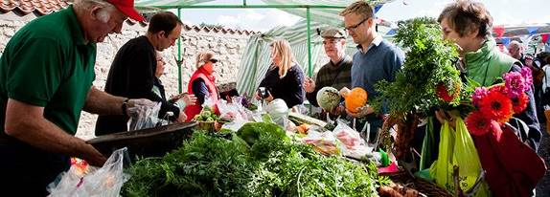

NEW FOR 2018.... YOUNG PROFESSIONALS NETWORK



One of HullBID’s greatest assets is our ability to bring business-people together and with this in mind we’ll be starting our ‘YOUNG PROFESSIONALS’ network.
An opportunity to meet with other young professionals from any sector in a relaxing and informal atmosphere. We plan to host foodie nights, social nights but also add a serious twist by introducing guest speakers that our professionals want to hear and learn from. These people are the city’s future... what are the job opportunities, how do we do our utmost to prevent this talent-base from straying elsewhere!

CITY OF CULTURE – BEYOND 2017

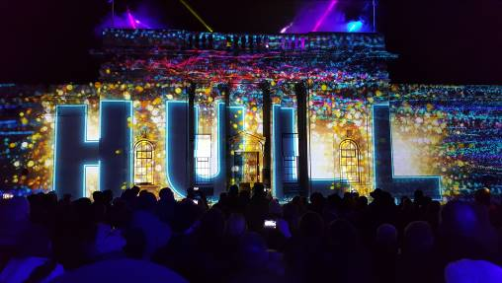
The astounding launch of City of Culture 2017 – ‘Made in Hull’, Queen Victoria Square

As a member of the Culture and Place Strategic Advisory Board (CAPSA), HullBID contributes a city centre business perspective, integral to the strategy for culture beyond 2017 through to 2026 supporting the legacy of City of Culture. The strategy will focus on three areas:

Developing the City:
City centre development and investment and culture must be aligned with each other reflecting the influence of city living in Northern Europe and Scandinavia creating a unique experience in the UK. A high quality cultural product that will enhance the image of Hull city centre.

HullBID’s existing events, given greater prominence and increasing attendance numbers in 2017, will continue with new, exciting initiatives announced as part of our business plan each year. Our events will complement the Culture Co’s programme but will still align with HullBID’s priorities of increasing footfall and enabling BID members to participate.

Developing the audience:
HullBID will work alongside/support partners and stakeholders to market Hull as a visitor destination whilst helping develop non-core audience. We will have greater engagement with partners to convey a united ‘visitor’ message. Additionally, work in education and skills will broaden the audience over time.

Developing the Sector:
A cultural partnership will provide the voice of culture in the city, fostering a new independence. The city’s plan for investment in culture will be developed in partnership with strategic stakeholders including HullBID. Data and services will be offered.

We are committed to offer every assistance to Hull City Council and the newly-formed Culture Company, continuing to build on the superb success of our year in the spotlight. The foundation has been laid and the cultural strategies adopted now will be integral to the city’s success.

FREQUENTLY ASKED QUESTIONS:

What is a BID?
A Business Improvement District (BID) is a defined geographical area where, in Hull’s case, the boundary covers the nucleus of the city centre bounded by Freetown Way,
the East Bank of the River Hull, the River Humber and Ferensway. Currently there are 287 Business Improvement Districts within the UK.

As a not for profit organisation (a company limited by guarantee), HullBID is funded and operated independently with its own team. HullBID represents the interests of approximately 745 member businesses across 1184 hereditaments.
Note: A hereditament is any business premise that is liable to pay business rates.

In the majority, a BID runs for a five year term as is the case with HullBID. Prior to expiry of the term, a renewal ballot takes place where businesses are given the opportunity to either vote in favour or against a BID being implemented.

Is HullBID under the control of Hull City Council?
HullBID is not run by the local authority, nor is it exclusively in the hands of businesses. As an independent organisation, it is designed to unite people from city centre business and from the providers of public services in partnership to identify and deliver the action that is needed to improve the area.

BIDs do not replace local authorities, police forces or other public bodies. Baseline service level agreements are set with those bodies and HullBID provides specific and enhanced improvements over and above statutory services.

How is HullBID funded?
HullBID is funded via an additional levy equivalent to 1% of the rateable value of a business premise. The levy is collected on behalf of HullBID by Hull City Council who send out an annual invoice approximately June time. Subject to a successful ballot, the levy is mandatory and all businesses are required to pay. Owners/landlords of unoccupied premises will still be required to pay the levy. Properties eligible for charitable relief of 80% of their non-domestic rates will be required to pay the levy on the remaining 20%.

How do you prioritise your spending?
We have prioritised spending according to our members’ wishes and carefully measure the success of each initiative. We are conscious our members' money needs to be well-controlled and spent thus we have deliberately kept our team small to manage one of the UK’s biggest BIDs.

In cost terms, how much is my business likely to pay?
Bearing in mind the levy is based on 1% of the RV of your business premise, below is an indication of the cost you will incur.

RV OF PROPERTY ANNUAL LEVY COST WEEKLY COST DAILY COST
£5,000 £50 £0.96 £0.14
£10,000 £100 £1.92 £0.27
£15,000 £150 £2.88 £0.41
£20,000 £200 £3.85 £0.55
£50,000 £500 £9.60 £1.37
£100,000 £1,000 £19.23 £2.75

Who pays the highest levy?
PREMISES | AMOUNT CONTRIBUTED
Hull City Council | £36,000
Tesco | £31,600
Primark | £8,150
House of Fraser | £7,900
Hull College | £7,300
Debenhams | £7,050
Hull Crown Court | £6,500
Princes Quay | £5,978
Boots | £5,817
Magistrates Court | £5,500

What are some of your significant achievements?
HullBID has achieved some great things over the last 5 years. The city centre is a measurably cleaner and safer place to do business. We’ve pulled together further with city stakeholders including Hull City Council, VHEY, Humberside Police and Civic 1 (the city’s CCTV operations hub). Our BID radio scheme goes from strength to strength, as do numbers attending our exciting events. Most importantly we have shown our strength as a lobbying organisation, bringing together businesses to take action on matters which affect Hull city centre.

FOOTFALL AND STATISTICS

We’ll closely monitor footfall gathered from our 7 footfall counters to measure any trends and draw comparisons with other cities. Up-to-date information on vacancy rates and new occupants / vacations will be presented on request.

DELIVERABILITY AND RISK

There are no technical or legal barriers from an organisational perspective that will prevent implementation and delivery of this plan.

CONTACT DETAILS
Kathryn Shillito, HullBID City Centre Manager. Tel: 01482 611889
Registered Office: 34-38 Beverley Road, Hull HU3 1YE www.hullbid.co.uk

Note: Business plan may be subject to change. Our funding is subject to fluctuation which may increase or decrease and will be reflected accordingly across our budget and our implementation of initiatives. At the time of writing, it is believed that all information contained is correct but no liability or responsibility can be attached to HullBID

