

BUSINESS PLAN – 2016/2017
(1 October 2016 to 30 September 2016)
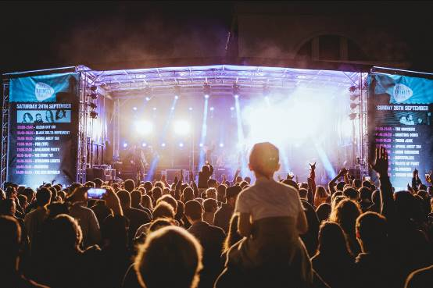
Hull Trinity Festival 2016. An event funded and organised entirely by HullBID. Image courtesy of Alasdair Jackson

EXECUTIVE SUMMARY
As we enter into our first year in BID Term 3, there is naturally a sense of pride and achievement having secured an 80% majority at the renewal ballot back in March. This will enable us to continue our great work... contributing to a greater standard of cleanliness, driving to ensure the city centre is adequately policed and providing an exciting calendar of events that will attract footfall and raise perceptions to those visiting. Just as importantly, we have brought the business community together, acting as a conduit to share information and raising awareness of the issues that affect our members.

As we progress into 2016/17, we do so with satisfaction that our strategy has been followed and we have recognised and addressed some of our shortcomings. We do not take our responsibility lightly – we know that the businesses who have contributed their hard earned money to HullBID have put us in a privileged position of trust and expect us to deliver.

Although we are seeing positive changes to the public realm which will widen appeal and dwell time in the city centre, the past year has been very challenging to business. What has emerged positively however is the determination of those businesses to continue and succeed; 2017 provides a raft of opportunities and the rewards will hopefully compensate for the hard times.

So... to 2017.... our year in the spotlight as UK City of Culture. A sensational first quarter has already been announced that will see Hull city centre brought to life. HullBID is perfectly positioned to act as liaison between the City of Culture team and city centre businesses, and we are proud to be recognised as the only independent body that can achieve this. With 1 million plus visitors expected it’s important our members are well-informed and benefit from the boost to our economy.

Hull City Council’s evolving City Plan is ambitious and bold.... there is lots to be excited about including the new state of the art conference/music venue and the proposed cruise terminal. It is a good time to attract investment, a good time show what ‘Brand Hull’ has to offer to the retail sector in particular and HullBID will be an integral part of this journey, working closely with our key partners.

We continue to have regular dialogue with our members on issues that affect them, from the successful Evening Economy Group meetings to smaller, trader group meetings. With our representation on the Public Realm Logistics Group and other Council-led groups, we are perfectly positioned to share news and information with our members. And.... we are at the end of a phone – always contactable, always approachable, always here to help.


Thank you - Kathryn Shillito, City Centre Manager, HullBID

FREQUENTLY ASKED QUESTIONS:

What is a BID?
A Business Improvement District (BID) is a defined geographical area where, in Hull’s case, the boundary covers the nucleus of the city centre bounded by Freetown Way,
the East Bank of the River Hull, the River Humber and Ferensway. Currently there are 251 Business Improvement Districts within the UK.

As a not for profit organisation (a company limited by guarantee), HullBID is funded and operated independently with its own team. HullBID represents the interests of approximately 780 member businesses across 1148 hereditaments.
Note: A hereditament is any business premise that is liable to pay business rates.

In the majority, a BID runs for a five year term as is the case with HullBID. Prior to expiry of the term, a renewal ballot takes place where businesses are given the opportunity to either vote in favour or against a BID being implemented.

Is HullBID under the control of Hull City Council?
HullBID is not run by the local authority, nor is it exclusively in the hands of businesses. As an independent organisation, it is designed to unite people from city centre business and from the providers of public services in partnership to identify and deliver the action that is needed to improve the area.

BIDs do not replace local authorities, police forces or other public bodies. Baseline service level agreements are set with those bodies and HullBID provides specific and enhanced improvements over and above statutory services.

How is HullBID funded?
HullBID is funded via an additional levy equivalent to 1% of the rateable value of a business premise. The levy is collected on behalf of HullBID by Hull City Council who send out an annual invoice approximately June time. Subject to a successful ballot, the levy is mandatory and all businesses are required to pay. Owners/landlords of unoccupied premises will still be required to pay the levy. Properties eligible for charitable relief of 80% of their non-domestic rates will be required to pay the levy on the remaining 20%.

How do you prioritise your spending?
We have prioritised spending according to our members’ wishes and carefully measure the success of each initiative. We are conscious our members' money needs to be well-controlled and spent thus we have deliberately kept our team small to manage one of the UK’s biggest BIDs.

In cost terms, how much is my business likely to pay?
Bearing in mind the levy is based on 1% of the RV of your business premise, below is an indication of the cost you will incur.

RV OF PROPERTY ANNUAL LEVY COST WEEKLY COST DAILY COST
£5,000 £50 £0.96 £0.14
£10,000 £100 £1.92 £0.27
£15,000 £150 £2.88 £0.41
£20,000 £200 £3.85 £0.55
£50,000 £500 £9.60 £1.37
£100,000 £1,000 £19.23 £2.75

Who pays the highest levy?
PREMISES | AMOUNT CONTRIBUTED
Tesco | 31600
Hull City Council | 27175
Primark | 8150
House of Fraser | 7900
Hull College | 7300
Debenhams | 7050
Hull Crown Court | 6500
Princes Quay | 5978
Boots | 5817
Magistrates Court | 5500

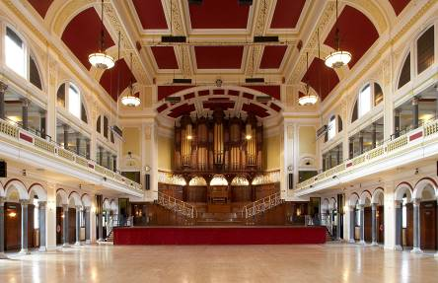
Hull City Hall. A Hull City Council-owned hereditament

What are some of your significant achievements?
HullBID has achieved some great things over the last 5 years. The city centre is a measurably cleaner and safer place to do business. Our partnership with Humberside Police and Civic 1 (the city’s CCTV operations hub) has really made a difference as the stats below demonstrate.

Year Totals | Shop Theft | Criminal Damage | Theft From the Person | Theft From Motor Vehicle
Apr 09 -Mar 10 | 986 | 291 | 151 | 62
Apr 10 - Mar 11 | 920 | 224 | 101 | 58
Apr 11 - Mar 12 | 818 | 174 | 104 | 56
Apr 12 - Mar 13 | 605 | 133 | 89 | 35
Apr 13 - Mar 14 | 695 | 143 | 60 | 17
Apr 14 - Mar 15 | 727 | 101 | 50 | 18
Apr 15 – Mar 16 | 771 | 153 | 64 | 51
Total reduction over the period | -22% | -47% | -58% | -77%
Source: Humberside Police, Riverside Neighbourhood Policing Team

We’ve continued to deliver successful events including Yum! Festival of Food and Drink, Hull Fashion Week and Hull Trinity Festival that have increased footfall and translated into increased revenue for participating businesses.

One of our greatest assets is our ability to bring businesses together with people that can make a difference... the decision-makers. We act as the conduit between Hull City Council - the Myton Ward Councillors particularly – so our businesses know first-hand of changes that will have an impact. Similarly we have direct access to Officers from Humberside Police who understand the important role HullBID plays in ensuring the city is as safe and secure as possible.

Our highly-respected Retail Security Forum brings together the Police, the anti-social behaviour officer and store security teams to share intelligence and data.

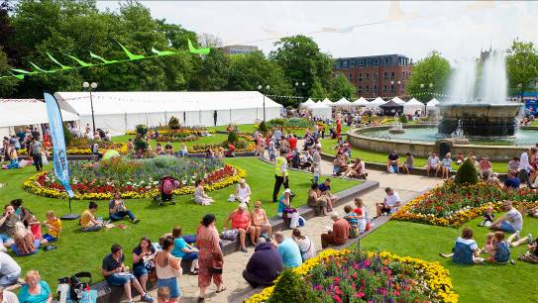
Image: An estimated 15,000 people enjoyed the Yum! Festival of Food and Drink – July 2016

What will the BID levy be spent on in 2016-2017?

In the 2016-2017 financial year we anticipate an income of approximately £489,713 from the BID levy and an additional £20,000 minimum will be raised via sponsorship etc. Below is an indicative budget (may be subject to change).

EXPENDITURE | ACTIVITY | APPROX. COST
Safety and Security | Ambassadors  Additional dedicated PCSO’s  Radios/CCTV | £76,907
Marketing and Events | Yum!  Fashion Week  HullBID Awards  Victorian Xmas/Edwardian Easter  Pride in Hull  Heritage Open Days  Christmas | £112,297
Communications | Newsletter  PR (for new member businesses)  Brochures/literature | £30,900
Rapid Response and lighting | Graffiti removal  Jet-spraying  Christmas lighting | £34,300
Evening Economy | Hull Trinity Festival  Street Food Events (x6) | £55,000
Access/Signage | Footfall counters  Empty unit graphics | £21,300
Management fees | Staffing  Chamber mgmt. fee  Rent/Utilities  Professional and sundry costs | £110,040
Levy collection/IT | Collection costs/IT upgrade – Hull City Council | £32,450
Contingency | - | £36,519
 | TOTAL | £509,713

Do HullBID draw in any extra funds?
We talk an awful lot about adding value and this comes in many forms including cash funding to in-kind support (which has a value). A few of our successes for the 2015-2016 year are outlined below and we will continue to demonstrate to potential sponsors the benefits of being a part of our activities and initiatives.

Source | Initiative/Activity | Amount
Oscars Bar, Old Town | Sponsorship of Hull Trinity Festival | £2500
Various Street Food operators | Concession taken at Hull Trinity Festival | £1780
HullBID Board Directors/BID members | Category Sponsors - Hull Business Improvement District Awards | £4500
Hugh Rice Jewellers | HullBID Fashion Week | £2500
Yum! Festival of Food and Drink | Concessions taken by non-BID members | £3500

O U R V I S I O N A N D S T R A T E G Y

OUR VISION…
‘A vibrant city of thriving businesses’
A reminder of what it is that we wish to achieve when we turn up to work – regardless of our individual role in the BID organisation. This is about our end goal. We know we play a key role in achieving this, but recognise we can’t do it on our own. We need to work in partnership with other city stakeholders groups and the business community. Our strategy reflects this awareness
OUR VALUES…
Our values provide a model for how we need to operate. We live these values everyday to ensure we realise our vision.

HullBID exists to help businesses in the city sustainably grow and progress. We will organise our activity around four key strategic pillars representing the important roles we play in facilitating the development of prosperity in Hull city centre.

These strategic pillars will remain constant irrespective of the actual activities. By staying true to our strategic pillars, we can adapt and change our tactical and operations plans to meet the changing needs of the business community whilst maintaining a consistent strategic and communicative approach.

OUR FOUR KEY STRATEGIC PILLARS
COMMUNICATION
INNOVATION
PROMOTION
COLLABORATION

Image: Delegates at a BID Business Networking Event

CORE PILLAR: COMMUNICATION
’We are visible, vocal and an active part of the business community’. Our objective is to be respected and recognised by at least 75% of levy paying businesses as a visible and active part of the business community.


This means that we will….

- Build credibility amongst key stakeholders in the city centre as an expert on Hull city centre growth and development.

- Increase spontaneous awareness amongst member businesses about the purpose of HullBID

- Engage levy payers and drive interest in getting involved in HullBID activities

- Facilitate member involvement and engagement in HullBID’s strategies; ensuring they have a voice

- Always respond to our levy payers in an appropriate and reasonable time frame

- Reflect on our values in all of our communications

- Encourage and provide opportunities for two-way communication

- Communicate, giving enough time to allow people to respond

How we’ll achieve our objectives:

- We will continue to revitalise our communications channels… website, newsletter, e news, to reflect our vision, values and purpose.

- An annual, comprehensive media and communications strategy will be implemented to raise greater awareness of city businesses and city activity

- Deliver a consistent relationship strategy and postcard/letter follow up.

- Represent our member businesses within all areas of the city centre with our partners Hull City Council and other stakeholders.

- Increase the number of HullBID Business Network Events to bi-monthly and target a wider sector of businesses.

- Our two dedicated HullBID Support Officers will communicate closely with our members, Humberside Police (including the ASBO team), retail security teams and over 200 BID radio users. There will be a collective approach to remove individuals demonstrating anti-social behaviour in the city centre.

- The HullBID Awards will provide recognition and reward to any member of any BID business. The 2017 Awards will again take place at the Mercure Hull Royal Hotel and shortlisted business will receive complimentary tickets.

- Our informative quarterly newsletter will include newsworthy topics... not just a glossy mag but a platform to showcase existing and new businesses.

- Any new member businesses will be offered personal PR support.

- Our dedicated Business Liaison Officer will schedule in immediate visits to new businesses offering a one-to-one service and deal with any issues arising therefrom (four per day)

Measurement of our success:

- Comprehensive press logs will be kept.
- Number of contacts made from the press (for interviews, quotes etc)
- Language used to describe Hull BID is positive
- Face to face feedback (number of visits/contacts)
- Survey results
- Network registrations and feedback
- Social media mentions
- Minutes will be retained on website

CORE PILLAR: INNOVATION
‘We plant and sow seeds and ideas’. Our objective is to develop 3 successful development initiatives in the 2016-2017 year.

This means that we’ll…

- Build a network to help share and promote events, initiatives and local companies.

- Plant the initial seed for ideas and events and let others continue when they’re established.

- Be assertive and active in driving Hull and its businesses forward.

- Focus on initiatives which make a measurable difference – don’t spread ourselves too thinly.

- Build confidence in our ability to initiate successful activities with impact.

How we’ll achieve our objectives…

- Actively solicit the input and expertise from Hull BID businesses – get them inspired and excited about the development of new ideas.

- Create a new forum of young entrepreneurs to seek ideas to reinvigorate the early evening economy. Continue to work with our established groups including the Public Realm Forum and Evening Economy Group.

- Work with each group to develop a pool of ideas for business development initiatives, resulting in a shortlist of top ten highest-impact, quickest-win ideas.

- Working with local food entrepreneurs, new ‘Street Food’ Events will be hosted from April to September (Thursday) in public squares to build on this growing national phenomenon.

- As a Healthy High Streets city, we will work with our partner businesses M&S, Greggs, Santander, EE, Boots and Wilko to ultimately help increase footfall, reduce the number of empty units and provide employment.

- We will research and develop a city centre ‘App’, signposting visitors to the best in retail, entertainment and dining as well as city attractions.

- We will organise an annual ‘Crime Prevention Day’ with an associated media campaign to highlight the support mechanisms available and utilise the services of the Police ‘Specials’ to recruit attendees.

- We will continue to fund footfall counters in 6 strategic locations enabling us to gauge an accurate picture of visitors and the paths they follow. The data will be analysed for trends and shared with our members.

Measurement of our Success
- Numbers of people attending group meetings and workshops
- 3 business boosting ideas chosen and implemented per year
- High level of support from BID businesses for ideas proposed (feedback, number of volunteers etc)
- Clear and measurable results from the implemented ideas.

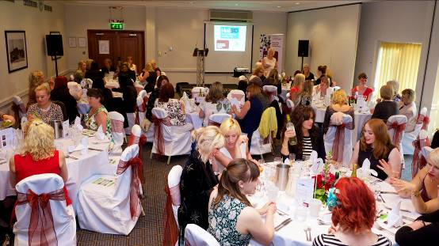
‘Inspiring Women’ Networking Dinner, part of Humber Biz Week – June 2016

CORE PILLAR: PROMOTION
‘We actively promote the benefits of visiting Hull city centre’. Our objective is to work with relevant agencies to promote the benefits of visiting Hull city centre and being directly responsible for increasing footfall each year.

This means that we’ll…
- Increase the number of HullBID members satisfied with our promotional and events based activities in the city to 75%

- Deliver relevant, high-quality events that measurably increase city centre footfall working in partnership where appropriate.

- Focus on improving Hull’s evening economy.

- Get to know which initiatives are really valuable and important to HullBID members and focus on delivering those.

- Make removing barriers and improving trading opportunities a key priority.

How we’ll achieve this objective…

- Continue to work with other agencies involved in promotion with a more coordinated approach and set objectives.

- Support Martin Green and the City of Culture team throughout their journey and contribute to the marketing coordination group to promote the city to its best advantage.

- Work cohesively with partner agencies to create a comprehensive calendar of events to increase footfall (and revenues) to the benefit of member businesses. Our activity will focus on three key events: Yum! Festival, Hull Trinity Festival and Christmas.

- We will update our Business Directory on the HullBID website to ensure each BID member is represented... a one-stop shop for any service.

- Working with our partners Hull City Council, Bondholders, VHEY and city retailers, we will host a stand at the British Council of Retail Centre event to showcase Hull city centre and thereafter facilitate familiarisation trips for potential investors.

- We will offer sponsorship packages for our key events to enable BID members to be involved and promote their individual business.

Measurement of our Success…

- Increased positive feedback on HullBID events by our members.
- Strong promotional partnerships built with other city stakeholders.
- Plans for a developed early evening economy emerge.

CORE PILLAR: COLLABORATION
‘We deal with the bigger issues that require a collective approach’. Our objective is to be considered the ‘champion of businesses by more than 70% of BID levy payers.

This means that we’ll…

- Build credibility amongst stakeholders in the city centre for being a conduit for business information.

- Build a network to help share and promote events and initiatives.

- Develop partnerships with other authorities and agencies to develop Hull city centre.

- Within our powers, we will lobby for the big issues that really make an impact.

- Continue to help keep the streets accessible, attractive and safe.

How we’ll achieve our objectives…

- Build and strengthen relationships with other authorities and agencies (Bondholders, Hull College, and the City of Culture Team).

- Continue to encourage businesses to attend working groups and forum meetings.

- Increase visits to businesses, delivering our ‘Welcome’ brochure and other literature.

- Ensure our crime and grime strategic plan is implemented across the city centre.

- Identify city-wide barriers to business through forums and develop strategies to address.

- We will continue to fund additional working hours of PCSOs in the city centre allowing us to direct extra policing to areas where it is most needed. We will utilise the free services of special constables at our outdoor events to help with security.

- We will build on our excellent relationship with Keith Hunter, Humberside Police and Crime Commissioner to help promote the city centre as a safe destination.

- The HullBID radio system – with over 200 users - provides round the clock access to BID Support Officers, the police and Civic 1 (the city’s CCTV hub). Radios are generally provided free of charge with all administration and training provided free.

- We will engage with Hull College and Hull University students to support graduation and open days and promote the city centre.

- Our work with the city’s Environmental Heath Team will ensure issues around illegal rubbish dumping and other waste are strictly dealt with and perpetrators brought to account.

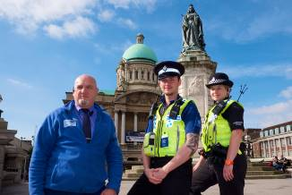
Mark Andrews, Senior HullBID Support Officer/city centre policing team

- Our rapid response hotline number 611888 provides an instant answer to businesses requiring our support. We will continue to react within 24 hours to remove graffiti, detritus and human waste.

- We will continue to support business by providing grounds maintenance and ad hoc painting as the need arises.

- A comprehensive cleaning and maintenance schedule will see our maintenance operative carrying out a coordinated jet-spraying/gum removal programme of specific areas of the city.

- We are committed to dressing unsightly empty retail units but we will also engage with landlords to look at ways we can collaborate to clean them up.

- We will organise at least two meetings per year with the leader of Hull City Council providing an opportunity for member businesses to speak directly and get answers to issues affecting them.

- Our place in the Indoor Market Working Group has enabled us to help shape the scheme and schedule of works. We will liaise closely with the Old Town Project Officer overseeing the new development.

- We are committed to seeking opportunities to provide free or reduced cost car parking within Hull city centre and will continue to engage with Hull City Council and independent operators. This will help attract footfall into the city.

Measurement of our Success

- Improvement in member perception scores
- Number of members attending forum meetings.
- Number of members sharing expertise and connecting using website area
- Number of lobby/campaigns/barrier removals successfully achieved.

OUR BOARD OF DIRECTORS
- Jim Harris, Centre Manager, St Stephens (Chair)
- Dr Ian Kelly, Chief Executive, Hull & Humber Chamber of Commerce
- Councillor Steven Bayes, Portfolio Holder for Visitor Destination, Hull City Council
- Jon Pywell, Assistant City Manager, City Lead (UK City of Culture), Hull City Council
- Claire Suggitt, Centre Manager, Princes Quay
- Lee Appleton, Centre Manager, Prospect Centre
- George Tambaros, Managing Director, A1 Developments Hull
- Guy Falkingham, Managing Director, Yorkshire Brewing Company
- Victoria Jackson MBE, Kingston Recruitment
- Tim Powell, Partner, Scotts
- Julie Buffey, Owner, Roisin Dubh
- David Hatfield, Station Manager North Humber and North Yorkshire, First TransPennine Express
- David Cooke, General Manager, Mercure Hull Royal Hotel
- Mike Rice, Chairman, Hugh Rice Jewellers

ALL BOARD DIRECTORS ARE VOLUNTEERS AND UNREMUNERATED

OUR OPERATIONAL TEAM
- Kathryn Shillito, City Centre Manager (full time)
- Catherine Goble, Marketing & Events Coordinator (full time)
- Mark Andrews, Senior Support Officer (full time)
- Raich Orr, Support Officer (full time)
- Melanie Toogood, Business Liaison Officer (part time)
- Francesca Sharp, PA (part-time)
- Martin Foster, Cleaning and Maintenance Operative

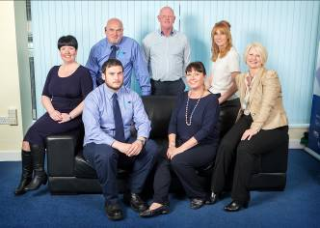
The HullBID Team

DELIVERABILITY AND RISK
There are no technical or legal barriers from an organisational perspective that will prevent implementation and delivery of this plan.

CONTACT DETAILS
Kathryn Shillito, City Centre Manager. Tel: 01482 611889
Registered Office: 34-38 Beverley Road, Hull HU3 1YE www.hullbid.co.uk

Note: Business plan may be subject to change. Our funding is subject to fluctuation which may increase or decrease and will be reflected accordingly across our budget and our implementation of initiatives. At the time of writing, it is believed that all information contained is correct but no liability or responsibility can be attached to HullBID

