

BUSINESS PLAN – 2014/2015
(1 October 2014 to 30 September 2015)

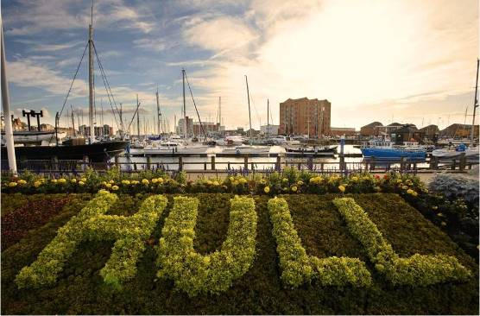

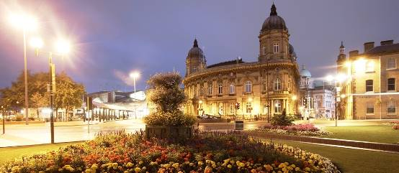

HULL BID AND THE BENEFIT IT BRINGS..What is HullBID?
A Business Improvement District (BID) is a defined geographical area where, in Hull’s case, the boundary covers the nucleus of the city centre bounded by Freetown Way, the East Bank of the River Hull, the River Humber and Ferensway.

As a not for profit organisation; a company limited by guarantee, HullBID is funded and managed independently with its own operational team. HullBID represents the interests of approximately 760 member businesses or 1121 hereditaments.
Note: A hereditament is any business premise that is liable to pay business rates.

Is HullBID under the control of Hull City Council?
BIDs are not run by the local authority, nor are they exclusively in the hands of businesses. They are designed to unite people from business and from the providers of public services in partnership to identify and deliver the action that is needed to improve their area.

BIDs do not replace local authorities, police forces or other public bodies. Baseline service level agreements are set with those bodies and HullBID provides specific improvements over and above statutory services using the funds provided by member businesses. In short, HullBID does not replace or subsidise existing services, it enhances them.

Across the UK there are over 170 Business Improvement Districts... an indication of the success BIDs bring to an area wishing to improve its trading environment.

How is HullBID funded?
HullBID is funded via an additional levy equivalent to 1% of the rateable value. The levy is collected on behalf of HullBID by Hull City Council who send out an annual invoice approximately June time. The levy is mandatory and all businesses are required to pay. Owners/landlords of unoccupied premises will still be required to pay the levy. Properties eligible for charitable relief of 80% of their non-domestic rates will be required to pay the levy on the remaining 20%.

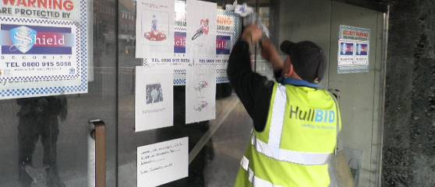

How much do BID member businesses contribute?
Businesses occupying new premises will be liable to pay the levy based on the rateable value at the time of occupation. The effective date for the levy will be the date the hereditament is entered into the non-domestic rating list.

INDICATIVE COSTS OF THE BID LEVY I.E. EQUIVALENT TO 1% OF THE RV OF BUSINESS PREMISE.
RV OF PROPERTY ANNUAL BID WEEKLY COST DAILY COST
£5,000 £50 £0.96 £0.14
£10,000 £100 £1.92 £0.27
£15,000 £150 £2.88 £0.41
£20,000 £200 £3.85 £0.55
£50,000 £500 £9.60 £1.37

£100,000 £1,000 £19.23 £2.75
£250,000 £2,500 £48.08 £6.87
£500,000 £5,000 £96.15 £13.74
£750,000 £7,500 £144.23 £20.60
£3,000,000 £30,000 £576.92 £82.42

Top ten highest levy payers:-
PREMISES | BANDING
Tesco | 31600
House of Fraser | 8600
Primark | 8150
Debenhams | 7050
Hull Crown Court | 6950
Hull Magistrates Court | 5500
M & S | 4925
Next | 4750
Boots | 4625
TK Maxx | 4225

Being Hull BID
We have made great efforts to engage with our businesses and increase communications so our members are fully in tune with our operations. Our City Centre Manager, Support Officers and Business Liaison Officer continue to schedule appointments with businesses to give us true insight into where our priorities should lie. We have dug deep, gained true responses and whilst acknowledging positive feedback, we had addressed criticism too.

As we progress into our 2014/2015 financial year, we do so with satisfaction that our strategy has been followed; we have recognised and addressed some of our shortcomings. We do not take our responsibility lightly – we know that the businesses who have contributed their hard earned money to HullBID have put us in a privileged position of trust and expect us to deliver.

Over the remainder of our term (until we go for our second renewal ballot in 2016), we have one clear, articulate vision – to repay the trust of our members by delivering a real, measurable difference. Everything that we do will add value and we will endeavour to measure the impact of all our activity; we are committed to action.

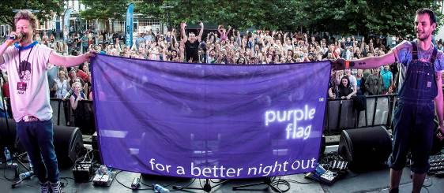

Significant Achievements
HullBID has already achieved some great things over the last eight years. The city centre is a measurably cleaner and safer place to do business and we’ve continued to deliver successful events including Yum Festival of Food and Drink, Fashion Week and Hull Trinity Festival that have increased footfall and translated into increased revenue for participating businesses.

HullBID and city stakeholders have been working hard to ensure we achieve re-accreditation for Purple Flag status. We had our Purple Flag inspection visit on the 1 November 2014 and we are feeling confident that we have maintained excellence in the management of Hull city centre on an evening.

We talk an awful lot about adding value and this comes in many forms including cash funding to in-kind support (which has a value). A few of our successes for the 2013/14 year are outlined below and we will continue to demonstrate to potential sponsors the benefits of being a part of our events and activities.

Community Safety Partnership | Funds to market/promote Purple Flag | £5000
Community Safety Partnership | Contribution towards Hull Trinity Festival | £2000
Humberside Police & Crime Commissioner | Funds to purchase 25 radios | £5500
Various businesses | Sponsorship towards Fashion Week/Yum! Festival/Trinity Festival | £5100
Various businesses | Sponsorship of Hull Business Improvement District Awards | £1200
Various businesses | Sponsorship of 2 BID Network Events | £800
One of our greatest assets is our ability to bring businesses together with people that can make a difference... the decision-makers. We act as the conduit between Hull City Council - the Myton Ward Councillors particularly – so our businesses know first-hand of changes that will have an impact. Similarly we have direct access to Officers from Humberside Police who attend our Evening Economy Group and Retail Group meetings to provide information and advice.

Our objective is to raise the profile of Hull city centre and through our good relationship with the Hull Daily Mail we have achieved this. Importantly though, we have helped our businesses receive media coverage they might not ordinarily aspire to. We offer the services of our PR Agent Phil Ascough at no cost and it is pleasing that around 80% of the news releases we have sent to the Hull Daily Mail have been published, each time reaching an audience of 140,000 readers and an additional 50,000 on-line readership. This in kind support is invaluable.



OUR STRATEGIC FOCUS
OUR MISSION…
Working in partnership with BID district organisations, we listen and respond to the needs of our members and create sustainable initiatives that make the Hull BID area a measurably better place to do business in.
OUR VISION…
‘A vibrant city of thriving businesses’
A reminder of what it is that we wish to achieve when we turn up to work – regardless of our individual role in the BID organisation. This is about our end goal. We know we play a key role in achieving this, but recognise we can’t do it on our own. We need to work in partnership with other city stakeholders groups and the business community. Our strategy reflects this awareness
OUR VALUES…
Our values provide a model for how we need to operate. We live these values everyday to ensure we realise our vision.

We Are Actively Connected
We have continual open and honest dialogue with BID businesses. Because of this we really understand what our members need from us. Everything we do is built on this understanding.

We Are Astutely Collaborative
We believe BID is successful when its stakeholders work like a team. We bring BID businesses and organisations together and motivate everyone towards the common vision and achieve results that benefit everyone

We Are Purposefully Focussed
We’re focussed on finding the right solutions to build a better future. We’re passionate about finding new opportunities to help the Hull BID businesses grow and prosper.

We Are Measurably Driven
We believe in delivering results that can be measured. We understand that our businesses are our stakeholders and they need and deserve to see a return on the investment they make in us.



OUR STRATEGY
HullBID exists to help businesses in the city sustainably grow and progress. We will organise our activity around four key strategic pillars representing the important roles we play in facilitating the development of prosperity in Hull city centre.

These strategic pillars will remain constant irrespective of the actual activities. By staying true to our strategic pillars, we can adapt and change our tactical and operations plans to meet the changing needs of the business community whilst maintaining a consistent strategic and communicative approach.

OUR FOUR KEY STRATEGIC PILLARS
COMMUNICATION
INNOVATION
PROMOTION
COLLABORATION

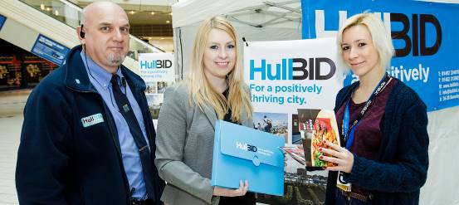

CORE PILLAR: COMMUNICATION
’We are visible, vocal and an active part of the business community’. Our objective is to be respected and recognised by at least 75% of levy paying businesses as a visible and active part of the business community.

This means that we will….

- Build credibility amongst key stakeholders in the city centre as an expert on Hull city centre growth and development.

- Increase spontaneous awareness amongst member businesses about the purpose of HullBID

- Engage levy payers and drive interest in getting involved in HullBID activities

- Build confidence amongst levy payers of HullBID’s ability to deliver meaningful growth

- Facilitate member involvement and engagement in HullBID’s strategies; ensuring they have a voice

- Always respond to our levy payers in an appropriate and reasonable time frame

- Reflect on our values in all of our communications

- Encourage and provide opportunities for two-way communication

- Communicate giving enough time to allow people to respond

How we’ll achieve our objective

- We will align and revitalise our communications channels… website, newsletter, e news, to reflect our new vision, values and purpose. We will inform levy paying businesses of the HullBID vision, KPI’s and activity plans.

- A comprehensive media and communications strategy will be implemented to raise greater awareness of city businesses and city activity

- We will develop our HullBID awards event for best practice (The BIDDIES)

- Develop a sustainable and consistent relationship strategy and postcard/letter follow up.

- Represent our member businesses within all areas of the city centre with our partners Hull City Council and other stakeholders.

- We will continue with our Retail Group Meetings. Although the name suggests otherwise, any member business may attend.

Measurement of our success:

- Comprehensive press logs will be kept.
- Number of contacts made from the press (for interviews, quotes etc)
- Language used to describe Hull BID is positive
- Face to face feedback (number of visits/contacts)
- Survey results
- Forum registrations and feedback
- Social media mentions
- Minutes will be retained on website

CORE PILLAR: INNOVATION
‘We plant and sow seeds and ideas’. Our objective is to develop at least 12 successful development initiatives (3 per year) by 2016.

This means that we’ll…

- Develop and launch 3 successful business development initiatives per year.

- Build a network to help share and promote events, initiatives and local companies.

- Plant the initial seed for ideas and events and let others continue when they’re established.

- Be assertive and active in driving Hull and its businesses forward.
- Focus on initiatives which make a measurable difference – don’t spread ourselves too thinly.

- Build confidence in our ability to initiative successful activities with impact.

How we’ll achieve our objectives…

- Actively solicit the input and expertise from Hull BID businesses – get them inspired and excited about the development of new ideas.

- Establish forums whilst continuing to work with our established groups including the Retail Group, the Marketing Group and our Evening Economy Group.

- Work with each group to develop a pool of ideas for business development initiatives, resulting in a shortlist of top ten highest-impact, quickest-win ideas.

- Implement the top 3 winning ideas each year.

Measurement of our Success
- Numbers of people attending our group meetings
- 3 business boosting ideas chosen and implemented per year
- High level of support from BID businesses for ideas proposed (feedback, number of volunteers etc)
- Clear and measurable results from the implemented ideas.

CORE PILLAR: PROMOTION
‘We actively promote the benefits of visiting Hull city centre’. Our objective is to work with relevant agencies to promote the benefits of visiting Hull city centre and being directly responsible for increasing footfall each year.

This means that we’ll…

- Increase the number of HullBID members satisfied with our promotional and events based activities in the city to 75%

- Deliver relevant, high-quality events that measurably increase city centre footfall working in partnership where appropriate.

- Focus on improving Hull’s evening economy.

- Get to know which initiatives are really valuable and important to HullBID members and focus on delivering those.

- Make removing barriers and improving trading opportunities a key priority.
How we’ll achieve this objective…

- Continue to work with other agencies involved in promotion with a more coordinated approach and set objectives.

- We will collaborate with Visit Hull and East Yorkshire to ensure we build a comprehensive marketing strategy.

- Develop a promotional and events campaign for the year to attract footfall including Fashion Week, Yum! Festival and Christmas activity.

- Lead an ‘Evening Economy’ Working Group.

- Deliver and Evening Economy action plan for implementation

Measurement of our Success…

- Increased positive feedback on HullBID events by our members.
- Strong promotional partnerships built with other city stakeholders.
- Robust plans for evening economy developed.
- Number of HullBID members engaged with ‘evening economy’ improvement plans.

CORE PILLAR: COLLABORATION
‘We deal with the bigger issues that require a collective approach’. Our objective is to be considered the ‘champion of businesses by more than 70% of BID levy payers by 2016.

This means that we’ll…
- Build credibility amongst stakeholders in the city centre for being a conduit for business information.

- Build a network to help share and promote events and initiatives.

- Develop partnerships with other authorities and agencies to develop Hull city centre.

- Lobby for the big issues that really make an impact.

- Continue to help keep the streets accessible, attractive and safe.

How we’ll achieve our objectives…

- Develop a successful lobby campaign (free parking, disincentives to prevent landlords leaving rental units vacant.

- Build and strengthen relationships with other authorities and agencies (Bondholders, Hull College, and University).

- Continue to encourage business to attend working groups and forum meetings.

- Increase visits to businesses, delivering our ‘Welcome’ brochure and other literature.

- Develop a crime and grime strategic plan.

- Identify city-wide barriers to business through forums and develop strategies to address.

Measurement of our Success

- Improvement in member perception scores
- Number of members attending forum meetings.
- Number of members sharing expertise and connecting using website area
- Number of lobby/campaigns/barrier removals successfully achieved.

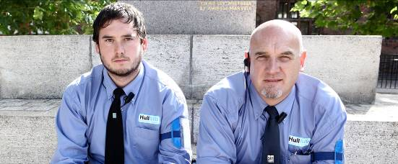

OUR BOARD OF DIRECTORS
- Jim Harris, Centre Manager, St Stephens (Chair)
- Dr Ian Kelly, Chief Executive, Hull & Humber Chamber of Commerce
- Councillor Steven Bayes
- Jon Pywell, Assistant Head of Service, Regeneration & Economic Development, Hull City Council
- Claire Suggitt, Centre Manager, Princes Quay
- Lee Appleton, Centre Manager, Prospect Centre
- George Tambaros, Managing Director, Hull & Humber Property Lettings
- Guy Falkingham, Managing Director, Blueprint
- Steven Marsay, Store Manager, Debenhams
- Steve Allbones, KCOM
- Victoria Jackson MBE, Kingston Recruitment
- Tim Powell, Scotts
- David Hatfield, First TransPennine Express

ALL BOARD DIRECTORS ARE VOLUNTEERS AND UNREMUNERATED

OUR OPERATIONAL TEAM
- Kathryn Shillito, City Centre Manager (full time)
- Alana Ennis, Projects & Events Manager (full time)
- Mark Andrews, Support Officer (full time)
- Raich Orr, Support Officer (full time)
- Melanie Toogood, Business Liaison Officer (part time)
- Francesca Sharp, PA (part-time)

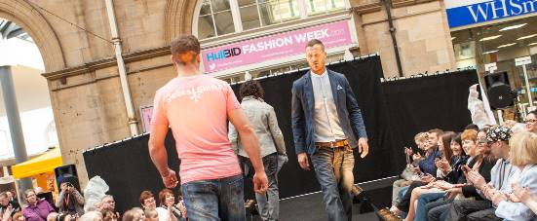

2014-2015 ONGOING AND PLANNED OPERATIONS ALIGNED WITH OUR CORE PILLARS (not exhaustive)

COMMUNICATION

- We will continue to fund two full-time HullBID Support Officers…. the eyes and ears of BID on the streets. They continue to collaborate closely with our businesses, Humberside Police (including the ASBO team), retail security teams and over 200 BID radio users to keep the city safe. They act as a conduit to feed out information on any matters which could affect our members, from road closures to Christmas lights switch on. They continue to monitor and work with partners to remove individuals demonstrating anti-social and drink-fuelled behaviour in the city centre.

- We will again host our Hull Business Improvement District Awards, providing a sense of recognition to any member of any BID business. The awards will encourage a strong sense of identity and positively raise the profile of city centre businesses, culminating in a grand finale awards ceremony in May 2015 at Hull Truck Theatre.

- We will conduct an on-line members’ survey; an opportunity for levy paying businesses to feedback their ideas and concerns in confidence which will help us re-shape our tactical plan moving forward.

- We will continue with our informative quarterly newsletter and endeavour to include newsworthy topics… not just a glossy mag but a vehicle to provide feedback on what we’ve achieved, how we continue to work with and utilise the services of our city partners and focusing on businesses new to the city centre

- Our dedicated Business Liaison Officer Melanie Toogood will schedule in a minimum of four visits to different businesses per day, sharing BID news and taking a proactive approach to dealing with issues, providing a response to queries within 14 days.

COLLABORATION
- We will continue to fund additional working hours of PCSOs in the city centre allowing us to direct extra policing to areas where it is most needed. We will utilise the free services of special constables at our outdoor events to help with security.

- We will build on our excellent relationship with Matthew Grove, Humberside Police and Crime Commissioner to help promote the city centre as a safe destination.

- The BID radio system goes from strength to strength and is highly regarded. Over 105 businesses hold at least one handset – providing round the clock access to the police and Civic 1 (the city’s CCTV hub). After a one-off cost to purchase the radio, all administration and training is provided free.

- We will engage with Hull College and Hull University students to support graduation and open days. We will take the opportunity to host stands at both institutions spreading the Purple Flag message and showcasing the city as a vibrant place to be.

- Our excellent working relationship with the city’s Environmental Heath Team will ensure issues around illegal rubbish dumping and other waste are strictly dealt with and perpetrators brought to account.

- Our rapid response hotline number 611888 provides an instant answer to businesses requiring our support. We will continue to react within 24 hours to remove graffiti, detritus and human waste. We will continue to support business by providing grounds maintenance and ad hoc painting as the need arises.

- A comprehensive cleaning and maintenance schedule will see our maintenance operative carrying out jet-spraying/gum removal of specific areas of the city.

- Our commitment to dressing unsightly empty retail units will continue but we will also engage with landlords to look at ways we can collaborate to clean them up.

- We will meet with the leader of Hull City Council providing an opportunity for member businesses to speak directly and get answers to issues affecting their part of town.

- We will continue to collaborate with Hull City Council to reinvigorate the Trinity Indoor Market.

- We are committed to seeking opportunities to provide free or reduced cost car parking within Hull city centre and will continue to engage with Hull City Council. This will help attract footfall into the city.

INNOVATION

- We have seen attendance increase by over 100% to our Retail Group Meetings and to our Evening Economy Group Meetings. Both provide a perfect vehicle to engage with our members and pool ideas for new business boosting initiatives. We will endeavour to increase attendance figures.

- We will focus on introducing initiatives that make a difference and withdraw from those that have become successful and self-sustaining.

- We will commit to organising four BID Business Networking Events per year, inviting guest speakers along that will add value. Attendees will provide feedback after each event via an on-line survey.

- We will continue to fund footfall counters in 6 key locations within Hull city centre enabling us to gauge an accurate picture of visitors and the paths they follow. Counters are stationed at Whitefriargate, Brook Street, St Stephens, Prospect Street, Jameson Street, King Edward Street. Comprehensive data is provided to help us ascertain our positioning compared with other regional cities. Current data can be found on our website.

PROMOTION

- HullBID will support Martin Green, Chief Executive of the City of Culture 2017 Company and his team throughout their journey. As the year approaches, we will collaborate on events and activities that will engage and thrill but importantly will drive footfall to our businesses.

- HullBID will work cohesively with partner agencies, particularly Hull City Council to create a comprehensive calendar of events to increase footfall (and associated revenues) to the benefit of member businesses. We will again focus on four key promotional events/activity for 2014/2015…. HullBID Fashion Week, the HullBID Yum! Festival of Food and Drink, Hull Trinity Festival and Christmas, seeking additional funding and support as we go. Strict measurement will ensure our investment has proved beneficial to supporting our member businesses

- We will increase our number of market gazebos to 29 and loan out to BID members* The Trinity Open Market in Trinity Square has firmly established itself and has been a real partnership between organiser Julie Buffey and HullBID. We see the value of a market helping drive footfall to this area of the city. *Note a small maintenance charge will be made

- HullBID will provide Christmas lighting to Brooke Street, Prospect Street, Hepworth’s Arcade, Paragon Arcade and Silver Street to promote the retail offering at this important time of the year.

- The achievement of Purple Flag re-accreditation by HullBID and city partners including the Police and Hull City Council will provide us with endless possibilities to promote the evening economy. We will ensure the branding is fully utilised on all literature and websites where appropriate. We will work with partner agencies including Hull & Humber Chamber of Commerce, Visit Hull & East Yorkshire and Hull Bondholders to get the message out.

- We will update and reprint our very successful dining out brochure. 10,000 copies will be printed and distributed – predominantly the Tourist Information Centre will be the main distribution channel.

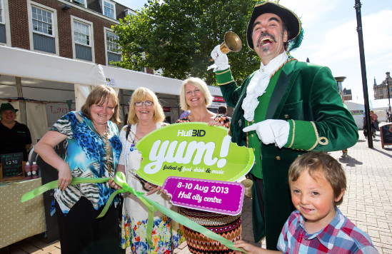

EXECUTIVE SUMMARY
Why do businesses need HullBID?
Simply put, we are committed to affect real change in Hull City Centre. Times are tough and we have to be competitive. We have to attract and keep new inward investment to see the city flourish.

HullBID has made significant achievements in our 6 year history drawing in around £1.9 million in additional funding and support and importantly we’ve achieved the Purple Flag status along with our partners.

Our members need a voice... representation to drive and affect change on issues that affect them and we are perfectly positioned to do this. Our regular meetings and dialogue with the leader and other senior personnel within the local authority allow us a unique lobbying platform

Our city centre will flourish if visitors continue to come; this will only happen if there are staged activities and events that contribute to a pleasing environment where there is lots to do. We constantly consult with our fellow stakeholders to create sustainable initiatives that make the HullBID area a better place to visit. A comprehensive calendar of events will ensure that footfall will increase.

The city is measurably cleaner and importantly safer... we know this because of our investment and onging work with Humberside Police and we are confident we’ll further improve on current statistics. We can only attract new occupiers to our properties that bring with them staff who are reassured about security.

Our increased personal visits to businesses and networking events will allow us to fully engage with our members, providing a clearer picture of what is required.

The BID Board and Operational Team are positively driven to implement a business plan that delivers.

DELIVERABILITY AND RISK
There are no technical or legal barriers from an organisational perspective that will prevent implementation and delivery of this plan.

CONTACT DETAILS
Kathryn Shillito, City Centre Manager. Tel: 01482 611889
Registered Office: 34-38 Beverley Road, Hull HU3 1YE www.hullbid.co.uk

Note: Business plan may be subject to change. Our funding is subject to fluctuation which may increase or decrease and will be reflected accordingly across our budget and our implementation of initiatives. At the time of writing, it is believed that all information contained is correct but no liability or responsibility can be attached to HullBID

