STEP-BY-STEP GUIDE FOR ERECTING YOUR GAZEBO:

Most of our gazebos can be easily erected by two people in under 60 seconds by following the instructions.

Step 1
Make the frame stand up and adjust some weight to one of the four corners, before stretching the entire frame out.
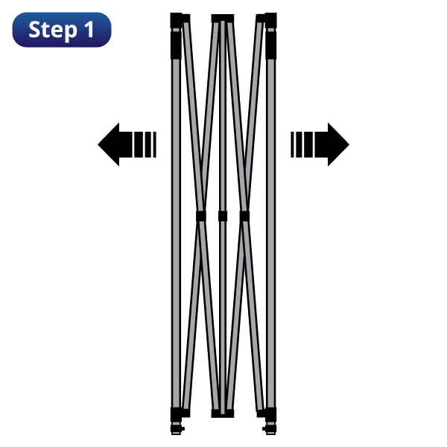
Step 2
Lift the frame by the lower part of the truss bars until the frame of the pop up gazebo is fully opened. This should make the frame fall into place. 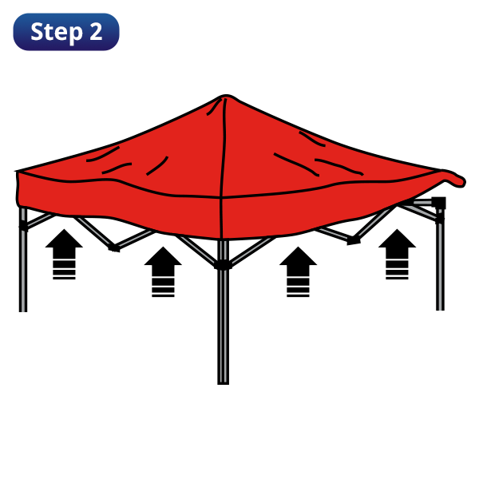
Step 3
Lock the gazebo slider bracket into place by holding the frame with one hand and lifting the slider bracket up into place until it locks. Pull the canopy down over the edges.
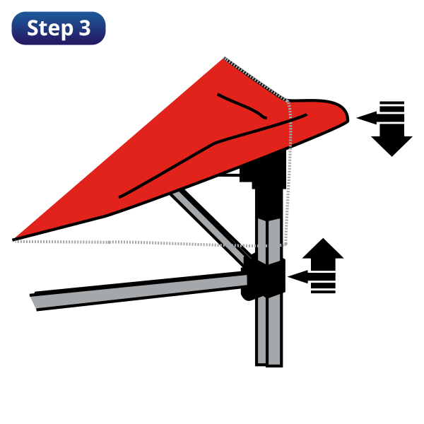
Step 4
Once the upper part of the gazebo is locked into place you can then pull down the canopy. Lift each leg and slowly pull out the inner leg until it pops into place. Repeat with each leg and adjust gazebo height by using the pull pin adjuster on the leg.

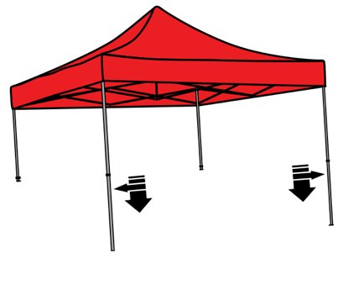

How Do I Anchor My Gazebo?
Without proper anchoring, a gazebo can be blown over and cause not only irreversible damage to the gazebo shelter itself, but could also lead to damaging other property. Your gazebo comes supplied with a standard tie down kit, suitable for soft ground. Alternatively, weights can be used on hard ground. We recommend 2 weights per corner.
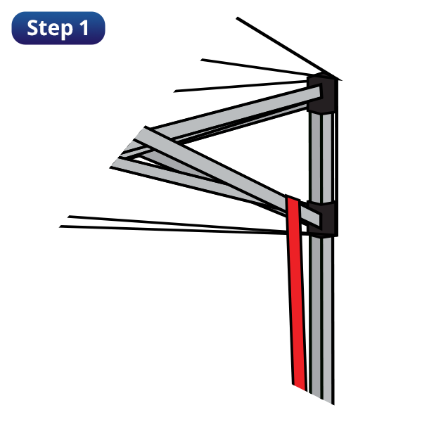

Best practice is to anchor the straps to the frame itself, and not the canopy. If the straps are attached to the canopy in severe wind, this can cause the material to rip, which will then be void under warranty. When securing your gazebo on hard standing ground – such as concrete or tarmac – we recommend the use of either steel stacking or sandbag leg weights.

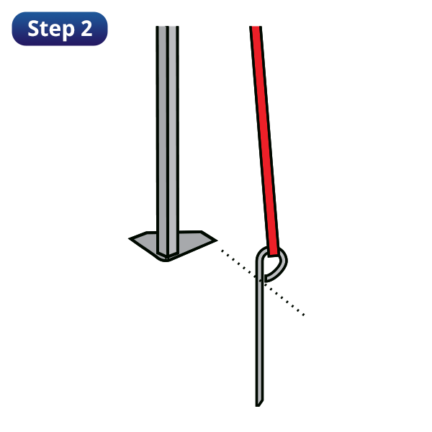

Where Do I Place My Gazebo?
Your gazebo can be placed on any even ground, yet even with the right equipment and know-how, a gazebo will not be safe to use if placed in a hazardous location. Proper placement of your gazebo is essential, both for aesthetic and safety reasons. For instance, avoid placing the gazebo underneath electrical lines (for obvious reasons). Keep children under close supervision if they are running around the gazebo, as anchoring guy ropes or straps could cause a trip hazard. Finally, do not assemble the gazebo if any part, big or small, is missing – it could prove crucial to the structure of the gazebo.

How To Dismantle Your Gazebo
Gazebos are not permanent structures should not be left unattended for prolonged periods of time, as they are only temporary structures. It is therefore imperative that people know how to disassemble their gazebo quickly and safely. For many of our gazebos, it is simply a case of reversing the steps for outlined above.

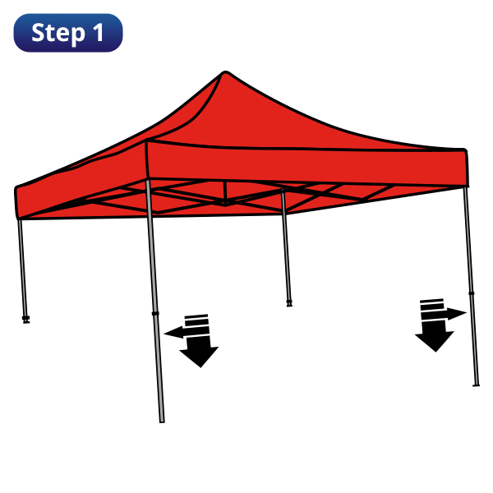
To start dismantling your gazebo, hold the outer leg, pull the pull pin height adjuster and slowly lower the frame until leg is fully retracted. Repeat this operation with each leg. Unlock the pull pin slider bracket and pull the slider bracket down slowly until the bracket is free from the locked position. Gently push the frame inward from the outer legs, allowing the frame to fold inward and close. Be careful not to pinch your fingers in the gazebo during closing! Completely fold the frame, making sure the canopy is not trapped between the crossbars.

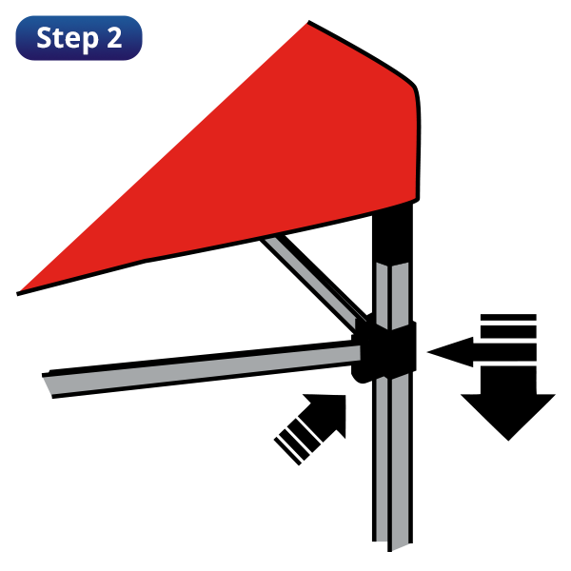
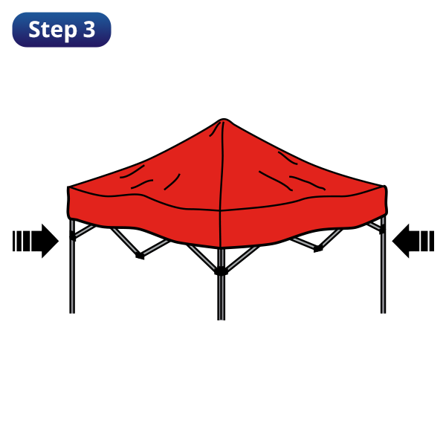

How To Store Your Gazebo
Ensure the canopy and walls are completely dry before storing for any length of time. If they are wet or damp when packing away after using the gazebo, you must unpack them and dry them out thoroughly before storing away. If gazebos are stored wet, damp will likely build up on the fabric, dulling the colour and sometimes even causing damage. Once discoloured, it is very difficult to restore a gazebo to its original condition. Therefore, make sure that you leave it out to dry before storing.

